|  |  |  |  |  |
| --- | --- | --- | --- | --- |
|  |  | | |  |
|  |  | | |  |
|  | First Row Seat Position Control  <<Feature>>  (F003516) | | |  |
|  |  | | |  |
| Document Type | **Feature Document (FD)** | | |  |
| Template Version | **6.1b** | | |  |
| SysML Report Template Version | **6.1b.2** | | |  |
| Document ID | **my25_frs_u71x_fd_2022-03-24** | | |  |
| Document Location |  | | |  |
| Document Owner | **Matthew Sahutske (msahuts1)** | | |  |
| Document Revision | **FD3** | | |  |
| Document Status | **Draft** | | |  |
| Date Issued | **2021/11/17** | | |  |
| Date Revised | **2021/11/19** | | |  |
| Document Classification | GIS1 Item Number: | **27.60/35** | |  |
| GIS2 Classification: | **Confidential** | |
|  | | | | |
|  | | | | |
| Document Approval | | | | |
| Person | Role | | Email Confirmation | Date |
|  |  | |  |  |
|  |  | |  |  |

**Auto-Generated by MagicDraw**

Printed Copies Are Uncontrolled

# Disclaimer

**This document contains Ford Motor Company Confidential information. Disclosure of the information contained in any portion of this document is not permitted without the expressed, written consent of a duly authorized representative of Ford Motor Company, Dearborn, Michigan, U.S.A.**

**Copyright, Ó 2021 Ford Motor Company**

This document contains information developed and accumulated by and for FORD MOTOR COMPANY. As such, it is a proprietary document, which, if disseminated to unauthorized persons, would provide others with restricted information, data, or procedures not otherwise available, exposing the FORD MOTOR COMPANY to potential harm.

Employees and suppliers having custody of this specification or authorized to use it must be cognizant of its proprietary nature and ensure that the information herein is not made available to unauthorized persons.

FORD MOTOR COMPANY reserves the right to protect this work as an unpublished copyrighted work in the event of an inadvertent or deliberate unauthorized publication. FORD MOTOR COMPANY also reserves its rights under copyright laws to protect this work as a published work.

This document or portions thereof shall not be distributed outside FORD MOTOR COMPANY without prior written consent. Refer all questions concerning disclosure to the author(s) or to any duly authorized representative of Ford Motor Company.

**Copyright** © **2021 Ford Motor Company**

# Contents

Disclaimer 2

Contents 3

1 Introduction 6

1.1 Document Purpose 6

1.2 Document Scope 6

1.3 Document Audience 6

1.3.1 Stakeholder List 6

1.4 Document Organization 6

1.4.1 Document Context 6

1.4.2 Document Structure 7

1.5 Document Conventions 7

1.5.1 Classification of Chapters 7

1.5.2 Requirements Templates 7

1.6 References 8

1.6.1 Ford Documents 8

1.6.2 External Documents and Publications 8

1.7 Glossary 8

1.7.1 Definitions 8

1.7.2 Abbreviations 8

1.7.3 Parameters / Values 8

2 Feature Overview 9

2.1 Purpose and Description of Feature 9

2.2 Feature Variants 11

2.2.1 Regions & Markets 13

2.3 Input Requirements/Documents 14

2.4 Lessons Learned 14

2.5 Assumptions 14

3 Feature Context 15

3.1 Feature Context Diagram 15

3.2 List of Influences 16

4 Feature Modeling 18

4.1 Operation Modes and States 18

4.2 Use Cases 20

4.2.1 Use Case Diagram 20

4.2.2 Actors 21

4.2.3 Use Case Descriptions 22

4.3 Driving and Operation Scenarios 25

4.4 Decision Tables 30

5 Feature Requirements 31

5.1 Functional Requirements 31

5.1.1 Error Handling 34

5.2 Non-Functional Requirements 34

5.2.1 Security 34

5.2.2 Reliability 34

5.2.3 Performance 34

5.3 HMI Requirements 34

5.4 Other Requirements 34

5.4.1 Design Requirements 34

5.4.2 Manufacturing Requirements 34

5.4.3 Service Requirements 34

5.4.4 After Sales Requirements 35

5.4.5 Process Requirements 35

6 Functional Safety 36

6.1 System Behaviors for HARA 36

6.2 Functional Safety Assumptions 37

6.3 Safety Goals 37

6.4 Functional Safety Requirements 38

6.4.1 Safety Goal: SG01 Unintended seat movement while the vehicle is in motion shall be prevented. 38

6.4.2 Derivation of Functional Safety Requirements on Assumptions 46

6.4.3 ASIL Decomposition of Functional Safety Requirements 46

7 CyberSecurity 47

7.1 Security Goals 47

7.2 Cybersecurity Requirements 47

8 Architecture 48

8.1 Functional Decomposition 48

8.1.1 Functions 53

8.2 Logical Architecture 54

8.2.1 Logical Elements 58

8.2.2 Logical Interfaces 60

9 Traceability Matrix 82

10 Open Concerns 85

11 Revision History 86

12 Appendix 87

12.1 Definitions 87

12.2 Abbreviations 92

**List of Figures**

Figure 2: Seat Switchback Location 9

Figure 2: Seat SwitchPack 10

Figure 2: Chauffeur Switch Motion 10

Figure 4: Feature Context 15

Figure 4: Feature Setup Context 16

Figure 5: Logical Operating Modes 18

Figure 6: Feature Use Cases 21

Figure 6: Learn Cycle Use Case 21

Figure 8: Control 1st Row Seat Comfort Positions 26

Figure 8: Control FRS Position to Support SRS Power Pitch/Slide 27

Figure 8: Learn 1st Row Seat Configuration Settings 29

Figure 8: Provide Easy Entry/Exit 29

Figure 9: Warning and Recovery Concept – Unintended seat movement while the vehicle is in motion shall be prevented. 42

Figure 1. Unintended seat movement while the vehicle is in motion shall be prevented. 43

Figure 1. Unintended seat movement while the vehicle is in motion shall be prevented. 43

Figure 10: Control 1st Row Seat Comfort Positions 49

Figure 10: Control FRS Position to Support SRS Power Pitch/Slide 50

Figure 10: Learn 1st Row Seat Configuration Settings 51

Figure 10: Provide Easy Entry/Exit 52

Figure 11: Front Driver Seat System 55

Figure 11: Front Passenger Seat System 56

Figure 11: FRS Logical Boundary Diagram 57

Figure 11: FRS System 58

**List of Tables**

Table 1: Features described in this FD 6

Table 2: Stakeholder’s list 6

Table 3: Ford internal Documents 8

Table 4: External documents and publications 8

Table 6: Feature Variants 13

Table 7: Regions & Markets 14

Table 8: Input Requirements/Documents 14

Table 9: List of Influences 17

Table 10: Operation Modes and States on Logical Operating Modes 19

Table 11: Transitions between Operation Modes and States on Logical Operating Modes 20

Table 12: List of Actors 22

Table 14: System Behaviors for HARA 37

Table 16: Functional Safety Goals 38

Table 17: Cybersecurity Goals 47

Table 19: List of Functions on Control 1st Row Seat Comfort Positions 53

Table 19: List of Functions on Control FRS Position to Support SRS Power Pitch/Slide 54

Table 19: List of Functions on Learn 1st Row Seat Configuration Settings 54

Table 19: List of Functions on Provide Easy Entry/Exit 54

Table 20: Logical Elements 60

Table 22: Feature Interactions on Front Driver Seat System 65

Table 22: Feature Interactions on Front Passenger Seat System 71

Table 22: Feature Interactions on FRS Logical Boundary Diagram 74

Table 22: Feature Interactions on FRS System 81

Table 23: Open Concerns *(Not supported by MagicDraw report generation)* 85

Table 24: Revision History 86

Table 25: Definitions used in this document 92

Table 26: Abbreviations used in this document 93

# Introduction

## Document Purpose

A Feature Document (FD) document defines a Feature on [Concept Level](https://bd101001.pd2.ford.com/stages/#/workspace/209/_vv/(process/activity/_Y6ftAPI2VsW5zd82DgHb6g)). It specifies **what** the feature shall do and how it shall behave from customer perspective. It should also provide reasoning and background **why** we have the feature in the vehicle.

The FD also serves as an Item Definition as defined by ISO26262 for those features, which follow the Ford Functional Safety process. Refer [FFSG01.10 Feature Document Guideline](https://azureford.sharepoint.com/sites/GlobalFunctionalSafety/Released%20Templates%20Guidelines%20and%20Examples/Guidelines/FFSG01.10_FeatureDocument_Guideline.pdf) for how to apply the Feature Doc template for Functional Safety.

## Document Scope

This Feature Document (FD) specifies the following features:

| **Feature ID** | **Feature Name** | **Owner** | **Reference** |
| --- | --- | --- | --- |
| F003516 | First Row Seat Position Control  (Program(s): 2025 U717, 2025 U718) | Matthew Sahutske (msahuts1) |  |

Table 1: Features described in this FD

## Document Audience

The FD is written by the feature owner of First Row Seat Position Control. All Stakeholders, i.e., all people who have a valid interest in the feature should read and, if possible, review the FD. It needs to be guaranteed, that all stakeholders have access to the currently valid version of the FD.

### Stakeholder List

For the latest list of stakeholder of the feature and their influence refer to <Put VSEM Link here>.

| **Name** | **CDSID** | **Contact Info** | **Role** | **Stakeholder Group** |
| --- | --- | --- | --- | --- |
| John Doe |  |  | Model Architect | Systems Engineer |

Table 2: Stakeholder’s list

## Document Organization

### Document Context

Refer to the [Specification Structure page](http://wiki.ford.com/display/RequirementsEngineering/Specification+templates) in the [Ford RE Wiki](http://wiki.ford.com/display/RequirementsEngineering/Requirements+Engineering+for+SW+Enabled+Features) to understand how the FD relates to other Ford Requirements Documents and Specifications.

### Document Structure

The structure of this document is explained below:

**Introduction** – Explains how to use this document including responsibilities and requisite documents. Explains the terminology. Gives a clarification of the definitions, concepts and abbreviations used in the document.

**Feature Overview** – States briefly the background and the purpose of the feature, feature variants and corresponding regions and markets. Also includes input requirements, assumptions, and constraints.

**Feature Context** – Describes all external entities, which have an influence on the feature.

**Feature Modeling** – Contains Use Case, Driving Scenarios, State Charts to describe the functional behavior of the feature.

**Feature Requirements** – Lists functional and non-functional requirements of the feature.

**Functional Safety** – Lists System Behaviors, Safety Goals and Safety Requirements of the feature.

**CyberSecurity** – Lists Security Goals and Security Requirements of the feature.

**Architecture** – Shows the coarse architecture, which the feature requirements are deployed to. Describes the elements and the boundary of the feature as well as the decomposition and distribution of associated functions.

**Traceability Matrix** – Traceability Matrix.

**Open Concerns** – List of Open Concerns

**Revision History** – Document Change History including a list of new or modified requirements. The requirements in this document are tagged, and this section contains different types of tables listing all, new, or changed requirements by their title and page no.

**Appendix** – Appendix

## Document Conventions

### Classification of Chapters

A chapter is considered mandatory, unless the chapter or its parent chapter(s) are categorized by using the tag:

**#Classification:** Some Condition

If no requirement/other content is known for a mandatory chapter, leave a statement “Not Applicable”

Some chapters have a follow certain rules in context of specific Ford processes, e.g. Functional Safety. This is indicated at the beginning of the corresponding chapter by the tags:

**#Functional Safety:** Some process specific explanation

**#Cybersecurity:** Some process specific explanation

### Requirements Templates

Refer to “[How to use the Specification Templates](http://wiki.ford.com/display/RequirementsEngineering/How+to+use+the+Specification+Templates?src=contextnavpagetreemode)” on how to use the specification templates and the VBA macros to create/edit the requirements in the specifications.

#### **Requirements Attributes**

The templates provided by *Specification_Macros.dotm* define a list of attributes for each requirement. This helps to classify the requirement. The attributes are explained at [RE Wiki - Requirements Attributes](http://wiki.ford.com/display/RequirementsEngineering/Requirements+Attributes?src=contextnavpagetreemode).

## References

### Ford Documents

List here all Ford internal documents, which are directly related to the feature.

| **Reference** | **Title** | **Doc. ID** | **Document Location** | **Revision** |
| --- | --- | --- | --- | --- |
| Ford GIS Standard | Ford GIS Standard |  |  |  |

Table 3: Ford internal Documents

### External Documents and Publications

The list of external documents could include books, reports and online sources.

| **Reference** | **Document / Publication** | **Document Location** |
| --- | --- | --- |
| IEEE Std 1012-2004 IEEE Standard for Software Verification and Validation |  |  |
| ISO/IEC 19500-2:2003 | Information technology -- Open Distributed Processing -- Part 2 |  |
| UML Testing Profile (UTP), v1.2 |  |  |
| Wikipedia |  |  |

Table 4: External documents and publications

## Glossary

See Appendix for Definitions and Abbreviations.

### Definitions

### Abbreviations

### Parameters / Values

No Parameters / Values specified.

# Feature Overview

## Purpose and Description of Feature

The First Row Seat Position Control feature is responsible for the following:

1) First row seat head rest up/down travel.

2) First row seat head rest fore/aft travel.

3) First row seat fore/aft travel.

4) First row seat up/down travel (seat height).

5) First row seat cushion tilt.

6) First row seat recline/incline (seatback).

7) First row seat upper thoracic travel.

8) First row seat left-thigh extension travel (in/out).

9) First row seat right-thigh extension travel (in/out).

10) First row passenger Chauffeur Switch.

11) First row seat lumbar fore/aft travel.

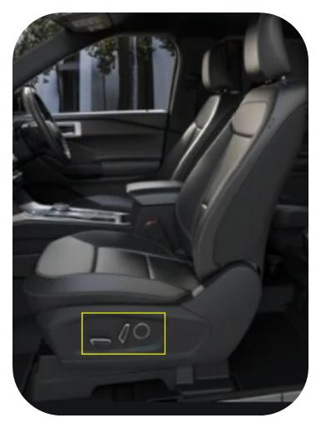

Figure 1: Seat Switchback Location

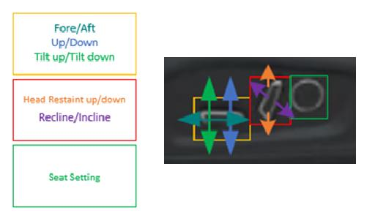

Figure 2: Seat SwitchPack

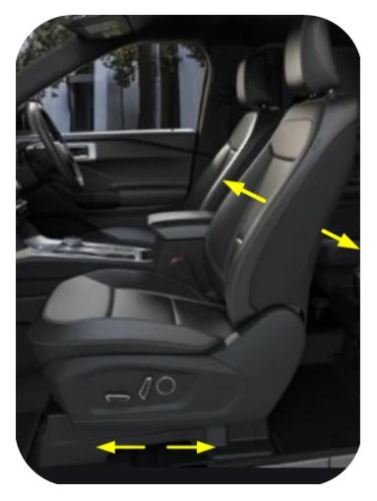

Figure 3: Chauffeur Switch Motion

## Feature Variants

| **Variant Name** | **Variant Description** | **Remarks** |
| --- | --- | --- |
| **Variant 10 - 2025 U717** | Driver First Row Seat interacts with the following:  1) Fore/Aft  2) Seat Height (Up/Down)  3) Tilt (Up/Down)  4) Lumbar (In/Out)  Passenger First Row Seat interacts with the following:  - No Power Functions |  |
| **Variant 11 - 2025 U717** | Driver First Row Seat interacts with the following:  1) Easy Entry/Exit  2) Seat Memory  3) Fore/Aft  4) Seat Height (Up/Down)  5) Seatback (Incline/Recline)  6) Lumbar (In/Out)  7) Tilt (Up/Down)  Passenger First Row Seat interacts with the following:  1) Fore/Aft  2) Seat Height (Up/Down)  3) Seatback (Incline/Recline)  4) Lumbar |  |
| **Variant 11a - 2025 U718** | Driver First Row Seat interacts with the following:  1) Easy Entry/Exit  2) Seat Memory  3) Fore/Aft  4) Seat Height (Up/Down)  5) Tilt (Up/Down)  6) Seatback (Incline/Recline)  Passenger First Row Seat interacts with the following:  1) Fore/Aft  2) Seat Height (Up/Down)  3) Seatback (Incline/Recline)  4) Tilt (Up/Down)  Note: This variant also includes Multi Contour Seats. |  |
| **Variant 13 - 2025 U718** | Driver First Row Seat interacts with the following:  1)    Easy Entry/Exit  2)    Seat Memory  3)    Fore/Aft  4)    Seat Height (Up/Down)  5)    Seatback (Incline/Recline)  6)    Left Thigh Extension  7)    Right Thigh Extension  8)    Tilt (Up/Down)  Passenger First Row Seat interacts with the following:  1)    Passenger Seat Memory  2)    Fore/Aft  3)    Seat Height (Up/Down)  4)    Seatback (Incline/Recline)  5)    Left Thigh Extension  6)    Right Thigh Extension  Note: This variant also includes Multi Contour Seats. |  |
| **Variant 13b - 2025 U718** | Driver First Row Seat interacts with the following:  1) Easy Entry/Exit  2) Seat Memory  3) Fore/Aft  4) Seat Height (Up/Down)  5) Tilt (Up/Down)  6) Seatback (Incline/Recline)  7) Left Thigh Extension  8) Right Thigh Extension  Passenger First Row Seat interacts with the following:  1) Passenger Seat Memory  2) Fore/Aft  3) Seat Height (Up/Down)  4) Tilt (Up/Down)  5) Seatback (Incline/Recline)  6) Left Thigh Extension  7) Right Thigh Extension  Note: This variant also includes Multi Contour Seats |  |
| **Variant 13c - 2025U718** | Driver First Row Seat interacts with the following:  1) Easy Entry/Exit  2) Seat Memory  3) Fore/Aft  4) Seat Height (Up/Down)  5) Tilt (Up/Down)  6) Seatback (Incline/Recline)  7) Left Thigh Extension  8) Right Thigh Extension  9) Power Pitch of 2nd Row Seat  10) Chauffeur Switch  Passenger First Row Seat interacts with the following:  1) Passenger Seat Memory  2) Fore/Aft  3) Seat Height (Up/Down)  5) Seatback (Incline/Recline)  6) Left Thigh Extension  7) Right Thigh Extension  8) Power Pitch of 2nd Row Seat |  |
| **Variant 15 - 2025 U718** | Driver First Row Seat interacts with the following:  1) Easy Entry/Exit  2) Seat Memory  3) Power Pitch of 2nd Row Seat  4) Fore/Aft  5) Seat Height (Up/Down)  6) Tilt (Up/Down)  7) Seatback (Incline/Recline)  8) Left Thigh Extension  9) Right Thigh Extension  10) Thoracic  11) Headrest (4 way)*  Passenger First Row Seat interacts with the following:  1) Power Pitch of 2nd Row Seat  2) Passenger Seat Memory  3) Fore/Aft  4) Seat Height (Up/Down)  5) Seatback (Incline/Recline)  6) Left Thigh Extension  7) Right Thigh Extension  8) Thoracic  9) Headrest (4 way)* |  |
| **Variant 16 - 2025 U718** | Driver First Row Seat interacts with the following:  1) Easy Entry/Exit  2) Seat Memory  3) Power Pitch of 2nd Row Seat  4) Chauffeur Switch  5) Fore/Aft  6) Seat Height (Up/Down)  7) Tilt (Up/Down)  8) Seatback (Incline/Recline)  9) Left Thigh Extension  10) Right Thigh Extension  11) Thoracic  12) Headrest (4 way)*  Passenger First Row Seat interacts with the following:  1) Power Pitch of 2nd Row Seat  2) Passenger Seat Memory  3) Fore/Aft  4) Seat Height (Up/Down)  5) Seatback (Incline/Recline)  6) Left Thigh Extension  7) Right Thigh Extension  8) Thoracic  9) Headrest (4 way)* |  |

Table 5: Feature Variants

### Regions & Markets

| **Market /**  **Region**  Variant Name | **North America** | **South America** | **Europe** | **Middle East/Africa** | **Asia / Pacific** | **China** |
| --- | --- | --- | --- | --- | --- | --- |
| **Variant 10 - 2025 U717** | Mandatory | Mandatory | No | Mandatory | Mandatory | No |
| **Variant 11 - 2025 U717** | Mandatory | Mandatory | No | Mandatory | Mandatory | No |
| **Variant 11a - 2025 U718** | Mandatory | Mandatory | No | Mandatory | No | No |
| **Variant 13 - 2025 U718** | Mandatory | No | No | Mandatory | Mandatory | Mandatory |
| **Variant 13b - 2025 U718** | No | No | No | No | No | Mandatory |
| **Variant 13c - 2025U718** | No | No | No | No | No | Mandatory |
| **Variant 15 - 2025 U718** |  |  |  |  |  |  |
| **Variant 16 - 2025 U718** |  |  |  |  |  |  |

Table 6: Regions & Markets

## Input Requirements/Documents

| **Reference**  (Reference as listed in ch. “**Error! Reference source not found.**”) | **Section/Requirement** | **Description** | **Derived Requirement**  (optional – reference to requirement in ch. “**Error! Reference source not found.**”) |
| --- | --- | --- | --- |
| **Attribute Requirements** | | | |
|  | Example AR |  |  |
|  | Comfort Adjustments | The vehicle shall allow the user's needs to be met for comfort in the FRS. |  |
| **Ford Engineering Standards** | | | |
|  | <Example: some SDS (requirement)> |  |  |
| **Legal Regulations** | | | |
|  | Compliance with FMVSS207 | The Feature shall comply with FMVSS207. |  |
|  | Compliance with FMVSS210 | The Feature shall comply with FMVSS210. |  |
| **Industry Standards** | | | |
|  | ISO 26262 | The system should be developed according to Ford's implementation of Functional Safety. |  |
| **Other Sources** | | | |

Table 7: Input Requirements/Documents

## Lessons Learned

No lessons learned specified.

## Assumptions

No Assumptions specified.

# Feature Context

## Feature Context Diagram

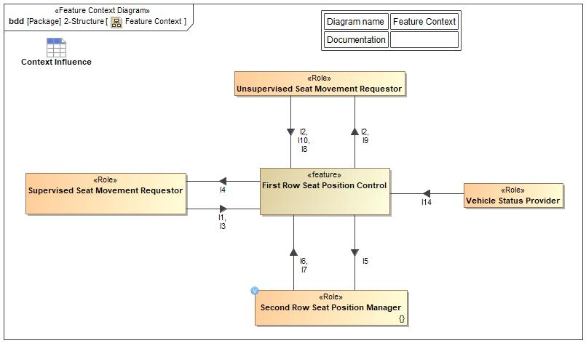

Figure 4: Feature Context

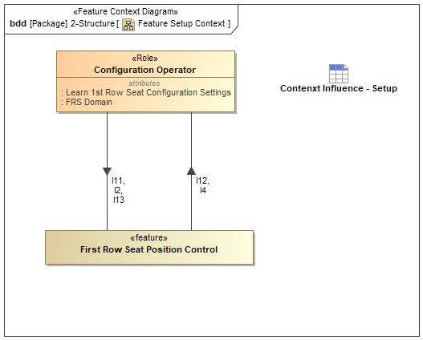

Figure 5: Feature Setup Context

## List of Influences

| **ID** | **External Entity** | **Influence Description** |
| --- | --- | --- |
| I1 | Supervised Seat Movement Requestor To First Row Seat Position Control | This information flow (FRSComfortSeatPositionRequest) represents the seat comfort commands that the user will select manually to move the FRS seats. |
| I2 | Configuration Operator To First Row Seat Position Control | This information item (SeatID) represents for which seat is being requested to move. |
| First Row Seat Position Control To Unsupervised Seat Movement Requestor | This information item (SeatID) represents for which seat is being requested to move. |
| Unsupervised Seat Movement Requestor To First Row Seat Position Control | This information item (SeatID) represents for which seat is being requested to move. |
| I3 | Supervised Seat Movement Requestor To First Row Seat Position Control | This information flow (ChauffeurRequest) represents the chauffeur request from the user to move the passenger FRS. |
| I4 | First Row Seat Position Control To Configuration Operator | This information item (SeatMovement) represents the physical seat movement. |
| First Row Seat Position Control To Supervised Seat Movement Requestor | This information item (SeatMovement) represents the physical seat movement. |
| I5 | First Row Seat Position Control To Second Row Seat Position Manager | This information item (FrontSeatPositionStatus) from the front row seat informs the second row seat of its position status to support power pitch and slide based on the fore/aft and incline/recline positions of the front row seat. |
| I6 | Second Row Seat Position Manager To First Row Seat Position Control | This information item (FirstRowStimuliRequest) requests that the front seat (that is in front of the second row seat that is being requested to move for easy entry/exit) needs to move forward (if needed) and incline to an upright position (if needed) to make room for second row seat to pitch forward. |
| I7 | Second Row Seat Position Manager To First Row Seat Position Control | This information item (FirstRowSeatReset) requests that the first row seat be returned to the "Initial" position. |
| I8 | Unsupervised Seat Movement Requestor To First Row Seat Position Control | This information item (RequestEasyEntry/Exit) represents the request for the FRS to move rearward/forward due to Easy Entry/Exit. |
| I9 | First Row Seat Position Control To Unsupervised Seat Movement Requestor | This information item (StoreFRSComfortPositions) represents the information of the FRS providing the seat positions to the Unsupervised Seat Movement Requestor. |
| I10 | Unsupervised Seat Movement Requestor To First Row Seat Position Control | This information item (AutomatedFRSComfortRequest) requests desired first row seat position from the Unsupervised Seat Movement Requestor to the first row seats to move unsupervised. |
| I11 | Configuration Operator To First Row Seat Position Control | This information item (RequestSeatConfigurationSetting) represents the Command from the "User" to set/learn configuration parameters. |
| I12 | First Row Seat Position Control To Configuration Operator | This information item (SetupStatusVisualFeedback) represents the visual feedback of the setup process completion status. |
| I13 | Configuration Operator To First Row Seat Position Control | This information item (SetupProcessSequence) represents the sequence at which the setup process will be completed. |
| I14 | Vehicle Status Provider To First Row Seat Position Control | This information item (VehicleStatus) provides the front row driver seat system with vehicle speed and transmission status to ensure that it can safely respond to unsupervised movement requests |

Table 8: List of Influences

# Feature Modeling

## Operation Modes and States

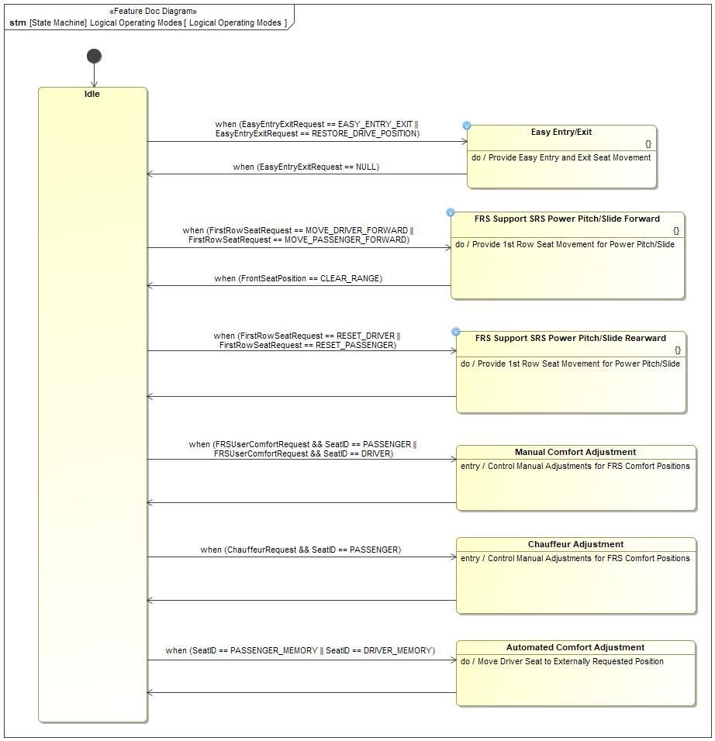

Figure 6: Logical Operating Modes

| **State** | **Description** | **Requirements Reference** (optional) |
| --- | --- | --- |
| Automated Comfort Adjustment | This state represents the automated FRS adjustments due to the request from the Unsupervised Seat Movement Requestor.  Do behavior: Move Driver Seat to Externally Requested Position |  |
| Chauffeur Adjustment | This state represents the FRS adjustments made for a chauffeur request. The incline/recline and fore/aft seat movements of the passenger FRS will be adjusted as requested.  Entry behavior: Control Manual Adjustments for FRS Comfort Positions |  |
| Easy Entry/Exit | This state represents the FRS actuation to support Easy Entry and Exit. The driver FRS will actuate rearward a predefined distance to provide the driver additional clearance to exit the vehicle and actuate forward once the driver has entered the vehicle and is ready to drive.  Do behavior: Provide Easy Entry and Exit Seat Movement |  |
| FRS Support SRS Power Pitch/Slide Forward | This state represents the FRS actuation to a predefined seat position to support SRS Power Pitch/Slide in the forward direction when requested by the SRS.  Do behavior: Provide 1st Row Seat Movement for Power Pitch/Slide |  |
| FRS Support SRS Power Pitch/Slide Rearward | This state represents the FRS actuation to the stored drive position to support SRS Power Pitch/Slide reset when requested by the SRS.  Do behavior: Provide 1st Row Seat Movement for Power Pitch/Slide |  |
| Idle |  |  |
| Manual Comfort Adjustment | This state represents the manual FRS adjustments due to the request from the Supervised Seat Movement Requestor.  Entry behavior: Control Manual Adjustments for FRS Comfort Positions |  |

Table 9: Operation Modes and States on Logical Operating Modes

| **Transition ID** | **Source** | **Destination** | **Description** | **Requirements Reference**  (optional) |
| --- | --- | --- | --- | --- |
| T1 | Chauffeur Adjustment | Idle |  |  |
| T2 |  |  |  |  |
| T3 | Idle | Chauffeur Adjustment | ChangeEvent when (ChauffeurRequest && SeatID == PASSENGER) |  |
| T4 | FRS Support SRS Power Pitch/Slide Forward | Idle | ChangeEvent when (FrontSeatPosition == CLEAR_RANGE) |  |
| T5 | Idle | Automated Comfort Adjustment | ChangeEvent when (SeatID == PASSENGER_MEMORY || SeatID == DRIVER_MEMORY) |  |
| T6 | Idle | FRS Support SRS Power Pitch/Slide Forward | ChangeEvent when (FirstRowSeatRequest == MOVE_DRIVER_FORWARD || FirstRowSeatRequest == MOVE_PASSENGER_FORWARD) |  |
| T7 | Idle | Easy Entry/Exit | ChangeEvent when (EasyEntryExitRequest == EASY_ENTRY_EXIT || EasyEntryExitRequest == RESTORE_DRIVE_POSITION) |  |
| T8 | Easy Entry/Exit | Idle | ChangeEvent when (EasyEntryExitRequest == NULL) |  |
| T9 | Manual Comfort Adjustment | Idle |  |  |
| T10 | Automated Comfort Adjustment | Idle |  |  |
| T11 | FRS Support SRS Power Pitch/Slide Rearward | Idle |  |  |
| T12 | Idle | Manual Comfort Adjustment | ChangeEvent when (FRSUserComfortRequest && SeatID == PASSENGER || FRSUserComfortRequest && SeatID == DRIVER) |  |
| T13 | Idle | FRS Support SRS Power Pitch/Slide Rearward | ChangeEvent when (FirstRowSeatRequest == RESET_DRIVER || FirstRowSeatRequest == RESET_PASSENGER) |  |

Table 10: Transitions between Operation Modes and States on Logical Operating Modes

## Use Cases

### Use Case Diagram

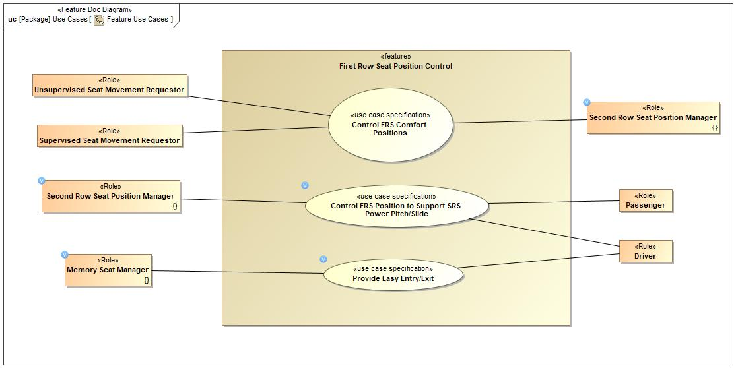

Figure 7: Feature Use Cases

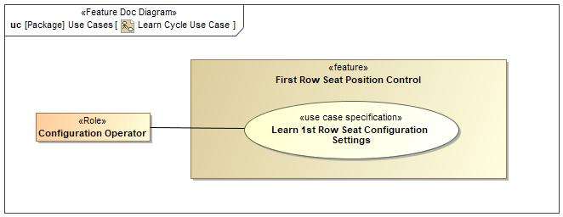

Figure 8: Learn Cycle Use Case

### Actors

| **Actor** | **Description** |
| --- | --- |
| Configuration Operator |  |
| Driver | This represents the Driver which will be driving the selections of the First Row Seat. |
| Memory Seat Manager | This Role represents the setting and recalling of a "Memory Seat". The following are features that can control it:  1) Personal Portable Profile (PPP)  2) Enhanced Memory  3) Classic Memory |
| Passenger | This represents the Passenger which will be driving the selections of the First Row Seat. |
| Second Row Seat Position Manager |  |
| Supervised Seat Movement Requestor |  |
| Unsupervised Seat Movement Requestor | This role represents |

Table 11: List of Actors

### Use Case Descriptions

Control FRS Position to Support SRS Power Pitch/Slide

|  |  |  |
| --- | --- | --- |
| **Actors** | Primary | Second Row Seat Position Control |
| Secondary |  |
| **Subject** |  | First Row Seat Position Control |
| **Description** |  |  |
| **Preconditions** |  |  |
| **Triggers** | T1 | Receive request to move from SRS. |
| **Main Flow Description** |  | FRS receives a request from SRS to move forward or rearward to support SRS pitch/slide. |
| **Main Flow** | M1 | 1a) Vehicle Occupant Requests Access to 3rd Row Seat via SRS. |
| M2 | 1b) Requested SRS sends a request to the FRS in front of the requested SRS to move forward. |
| M3 | 1c) FRS in front of the requested SRS sends its position to the requested SRS. |
| M4 | 1d) The requested FRS moves forward (if necessary). |
| M5 | 2a) Vehicle Occupant requests pitched SRS to pitch/slide rearward (reseat). |
| M6 | 2b) Requested SRS requests FRS in front of it to return to its "Initial" Position. |
| M7 | 2c) The requested FRS moves rearward to the "Initial" Position. |
| **Exceptional Flow Description** |  | The FRS runs into an obstacle while moving to the requested FRS positions to support SRS Pitch/Slide. |
| **Exceptional Flow Steps** | E1 | If the FRS runs into an obstacle, the FRS will reverse a predefined distance for the impeded seat movement and stop all other seat movements. |
| **Postconditions** | PostC1 | 1) The requested FRS is in the "Enabled" Position. |
| PostC2 | 2) The requested FRS is in the "Initial" Position. |

Learn 1st Row Seat Configuration Settings

|  |  |  |
| --- | --- | --- |
| **Actors** | Primary | Configuration Operator |
| Secondary |  |
| **Subject** |  | First Row Seat Position Control |
| **Description** |  |  |
| **Preconditions** |  |  |
| **Triggers** | T1 | Receives Learn Request. |
| **Main Flow Description** |  | Configuration Operator requests for Learn Cycle |
| **Main Flow** | M1 | Configuration Operator requests to learn 1st Row Seat end-point positions. |
| M2 | The 1st Row Seat comfort positions will move to the end-points of each seat movement. |
| M3 | The range between the end-points of each seat movement will be validated to a predetermined target range and save the end-point positions. |
| **Exceptional Flow Description** |  | The FRS runs into an obstacle while moving to the requested FRS positions for the Learning Cycle. |
| **Exceptional Flow Steps** | E1 | If the FRS runs into an obstacle, the FRS will reverse a predefined distance for the impeded seat movement and stop all other seat movements. |
| E2 | The Learn Cycle process will be terminated and the status will be displayed to the Configuration Operator. |
| **Postconditions** | PostC1 | After completing the learning cycle for a FRS, the status of the learn cycle will be displayed to the Configuration Operator. |

Control FRS Comfort Positions

|  |  |  |
| --- | --- | --- |
| **Actors** | Primary |  |
| Secondary | Memory Seat Manager |
| **Subject** |  | First Row Seat Position Control |
| **Description** |  |  |
| **Preconditions** |  |  |
| **Triggers** | T1 | Receives FRS comfort request |
| **Main Flow Description** |  | 1) Vehicle Occupant selects Comfort adjustments, or  2) Vehicle Occupant selects memory selection |
| **Main Flow** | M1 | Vehicle Occupant requests a 1st row seat to move to the requested comfort position. |
| M2 | The requested 1st row seat moves to the requested comfort position. |
| **Alternative Flow Description** |  | Vehicle Occupant selects Memory Recall. |
| **Alternative Flow Steps** | A1 | Vehicle Occupant selects a memory setting for recall. |
| A2 | FRS moves to the set memory comfort positions. |
| **Exceptional Flow Description** |  | Vehicle Occupant interrupts an ongoing memory seat adjustment by manually selecting a comfort adjustment. |
| **Exceptional Flow Description** |  | The FRS runs into an obstacle while moving to the requested memory comfort position. |
| **Exceptional Flow Steps** | E1 | If the FRS runs into an obstacle, the FRS will reverse a predefined distance for the impeded seat movement and stop all other seat movements. |
| E2 | If movement to requested memory comfort position is interrupted by a manual comfort position request, stop all seat movement for the interrupted FRS. |
| **Postconditions** | PostC1 | 1) After the Vehicle Occupant stops requesting a comfort setting, the requested FRS is in the desired comfort position. |
| PostC2 | 2) The FRS is in the desired seat position as requested by the external requestor. |

Provide Easy Entry/Exit

|  |  |  |
| --- | --- | --- |
| **Actors** | Primary | Memory Seat Manager |
| Secondary |  |
| **Subject** |  | First Row Seat Position Control |
| **Description** |  |  |
| **Preconditions** | PreC1 | Seat is in Easy Entry position |
| **Triggers** | T1 | Receive Easy Entry/Exit seat adjustment request |
| **Main Flow Description** |  | Memory Seat requests Easy Exit/Entry. |
| **Main Flow** | M1 | 1) Memory Seat requests for Driver seat to move a predefined distance rearward for Easy Exit. |
| M2 | 2) Memory Seat requests for Driver seat to move forward to back to the initial drive position for Easy Entry. |
| **Exceptional Flow Description** |  | The Driver FRS runs into an obstacle while moving to the requested Easy Entry and Exit positions. |
| **Exceptional Flow Steps** | E1 | If the Driver FRS runs into an obstacle, the FRS will reverse a predefined distance for the impeded seat movement and stop all other seat movements. |
| **Postconditions** | PostC1 | 1) The Driver FRS is in position at "Easy Entry and Exit Distance" rearward from the "Drive" Position to make it easy for the Driver to exit the vehicle. |
| PostC2 | 2) The Driver FRS is in the "Drive" Position. |

## Driving and Operation Scenarios

Control 1st Row Seat Comfort Positions

Diagram showing object flows for the supervised and unsupervised movement of the first row seats

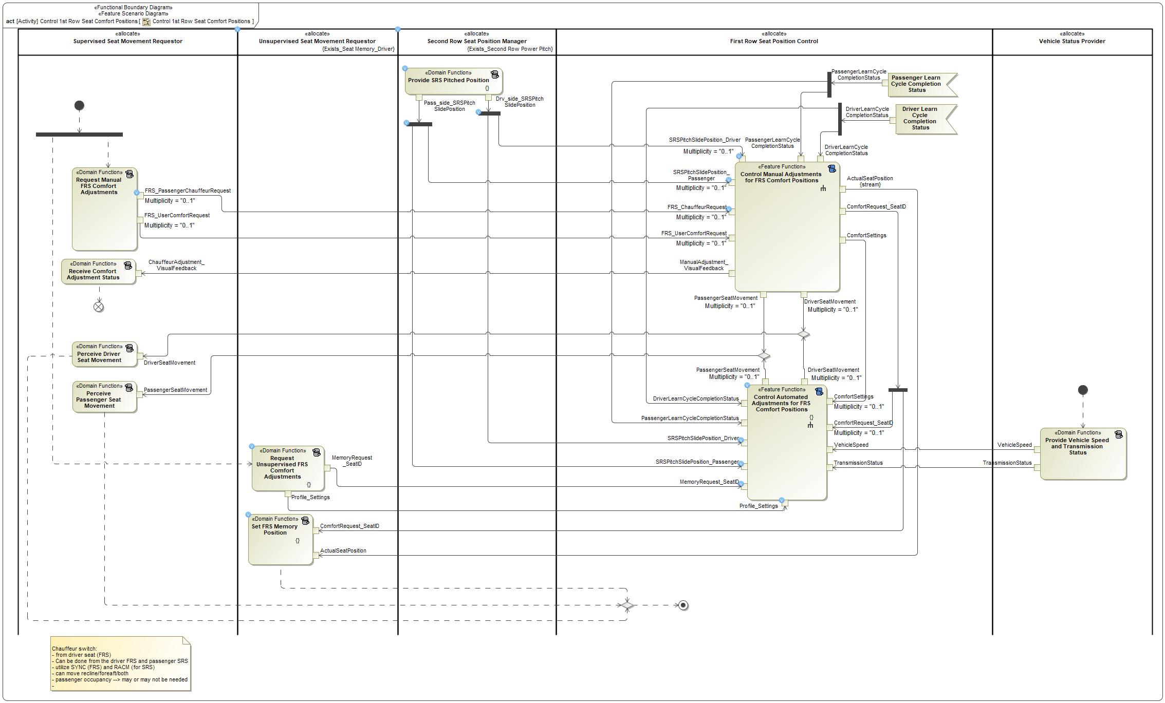

Figure 9: Control 1st Row Seat Comfort Positions

Control FRS Position to Support SRS Power Pitch/Slide

This activity diagram outlines the concept level object flows to support SRS power pitch/slide

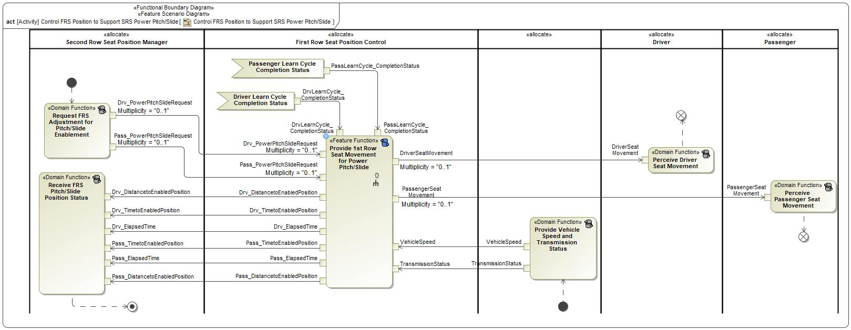

Figure 10: Control FRS Position to Support SRS Power Pitch/Slide

Learn 1st Row Seat Configuration Settings

Concept level activity diagram for FRS learn cycle

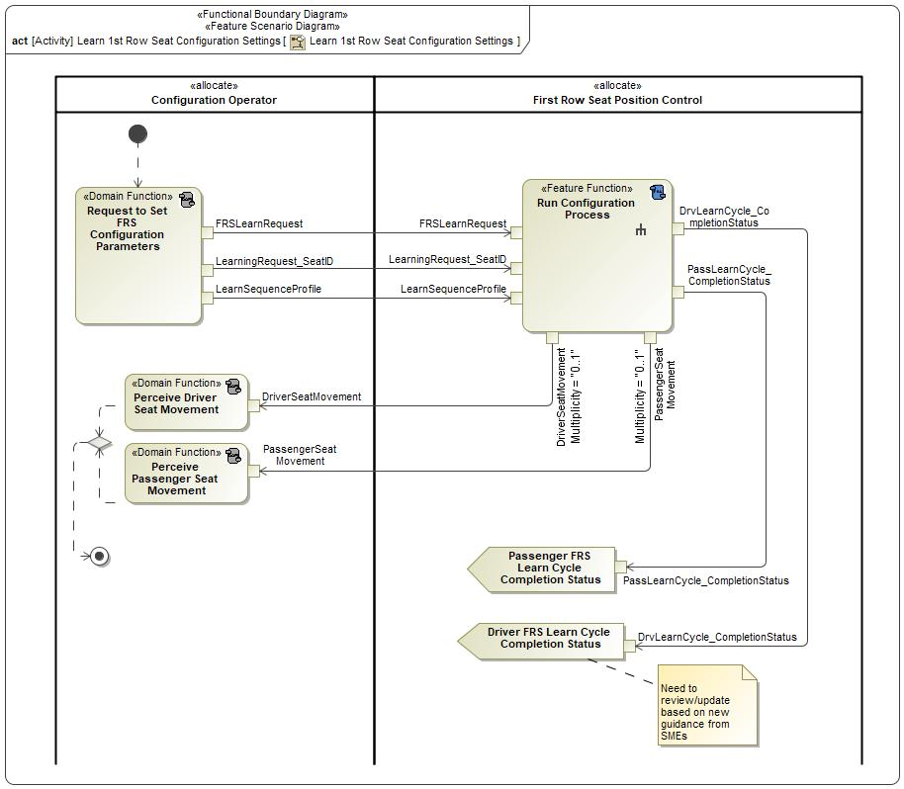

Figure 11: Learn 1st Row Seat Configuration Settings

Provide Easy Entry/Exit

Activity diagram to show the object flows needed to support easy entry/exit for the FRS Driver's seat

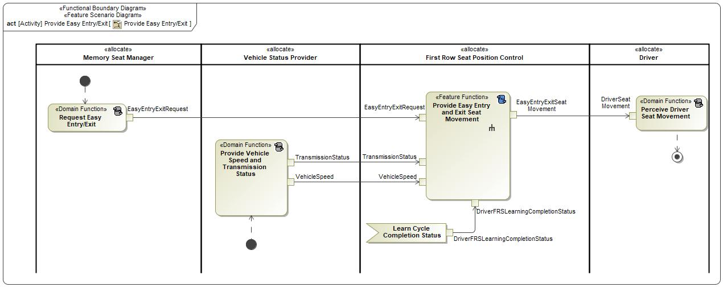

Figure 12: Provide Easy Entry/Exit

## Decision Tables

# Feature Requirements

## Functional Requirements

R_F_FRS_0001 1st Row PPSEEE "Enabled" Position

When requested by the "Second Row Seat Position Control" Feature, the "First Row Seat Position Control" Feature shall ensure the 1st row seat is in the "Enabled" Position for pitch/slide of the 2nd row seat.

|  |  |  |  |  |  |  |  |
| --- | --- | --- | --- | --- | --- | --- | --- |
| Requirement ID: R_F_FRS_0001 | | | | | | | |
| **Rationale** | To guarantee the 2nd row seat pitches/slides without hinderance. | | | | | | |
| **Acceptance Criteria** | Per user request of a 2nd row seat pitch/slide forward, 1st row seat moves to a predefined position to allow the 2nd row seat to pitch/slide forward. | | | | | | |
| **Notes** | If the 1st row seat is in a position which will hinder the 2nd Row Seat Pitch/Slide, the 2nd row seat will request the 1st Row Seat to move to the "Enabled" Position. | | | | | | |
| **Source** |  | | | | | **Owner** | Diana Aguilar |
| **Source Req.** |  | | | | | **V&V Method** | Visual inspection of the 1st row seat location from start to finish of the pitch/slide process. |
| **Type** |  | | | **Priority** | 1 - High | **Status** | In-Progress |
| [Req. Template](http://wiki.ford.com/display/RequirementsEngineering/Requirements+Attributes) Version | | 6.0 | End of Requirement | | | | |

R_F_FRS_0002 Provide FRS Position - PPSEEE

When requested by the "Second Row Seat Position Control" Feature, the "First Row Seat Position Control" Feature shall provide the position of the FRS.

|  |  |  |  |  |  |  |  |
| --- | --- | --- | --- | --- | --- | --- | --- |
| Requirement ID: R_F_FRS_0002 | | | | | | | |
| **Rationale** | So that the SRS will know if it is able to begin its pitch/slide forward. | | | | | | |
| **Acceptance Criteria** | When the SRS begins to pitch/slide forward, the FRS shall be out of the way so that contact is not made between the FRS and the SRS. | | | | | | |
| **Notes** | The FRS provides its position to the SRS so that the SRS can determine when it can begin to pitch/slide forward. | | | | | | |
| **Source** |  | | | | | **Owner** | Diana Aguilar |
| **Source Req.** |  | | | | | **V&V Method** | Visual inspection of the 1st Row Seat and 2nd Row Seat not coming into contact with each other. |
| **Type** |  | | | **Priority** | 1 - High | **Status** | In-Progress |
| [Req. Template](http://wiki.ford.com/display/RequirementsEngineering/Requirements+Attributes) Version | | 6.0 | End of Requirement | | | | |

R_F_FRS_0003 Easy Entry

When the user starts the vehicle, the "First Row Seat Position Control" Feature shall move the seat to the last driving position.

|  |  |  |  |  |  |  |  |
| --- | --- | --- | --- | --- | --- | --- | --- |
| Requirement ID: R_F_FRS_0003 | | | | | | | |
| **Rationale** | To allow easy entry into the vehicle. | | | | | | |
| **Acceptance Criteria** | When the user starts the vehicle, the FRS moves forward. | | | | | | |
| **Notes** | When the user enters the vehicle and starts it, the FRS shall move to its previous driving position. | | | | | | |
| **Source** |  | | | | | **Owner** | Diana Aguilar |
| **Source Req.** |  | | | | | **V&V Method** | Visual inspection that the FRS moves forward. |
| **Type** |  | | | **Priority** | 1 - High | **Status** | In-Progress |
| [Req. Template](http://wiki.ford.com/display/RequirementsEngineering/Requirements+Attributes) Version | | 6.0 | End of Requirement | | | | |

R_F_FRS_0004 Easy Exit

When the user turns the vehicle off, the "First Row Seat Position Control" Feature shall move the seat rearward to allow easy exit.

|  |  |  |  |  |  |  |  |
| --- | --- | --- | --- | --- | --- | --- | --- |
| Requirement ID: R_F_FRS_0004 | | | | | | | |
| **Rationale** | To allow easy exit out of the vehicle. | | | | | | |
| **Acceptance Criteria** | When the user turns the vehicle off, the FRS moves rearward. | | | | | | |
| **Notes** | When the user turns the vehicle off, the FRS shall move to a rearward position. | | | | | | |
| **Source** |  | | | | | **Owner** | Diana Aguilar |
| **Source Req.** |  | | | | | **V&V Method** | Visual inspection that the FRS moves rearward. |
| **Type** |  | | | **Priority** | 1 - High | **Status** | In-Progress |
| [Req. Template](http://wiki.ford.com/display/RequirementsEngineering/Requirements+Attributes) Version | | 6.0 | End of Requirement | | | | |

R_F_FRS_0005 Recall Memory

When requested by memory, the "First Row Seat Position Control" Feature shall move FRS to the position stored in memory and provide the Seat Movement of the requested "SeatID" to the "Vehicle Occupant".

|  |  |  |  |  |  |  |  |
| --- | --- | --- | --- | --- | --- | --- | --- |
| Requirement ID: R_F_FRS_0005 | | | | | | | |
| **Rationale** | To provide easy adjustment of the comfort settings to a previously stored comfort position. | | | | | | |
| **Acceptance Criteria** | Per user request of the memory "Recall" settings, the vehicle shall recall the comfort settings from memory. | | | | | | |
| **Notes** | Stored Comfort positions shall be recalled from memory. | | | | | | |
| **Source** |  | | | | | **Owner** | Diana Aguilar |
| **Source Req.** |  | | | | | **V&V Method** | Movement of seat comfort positions for the saved memory recall. |
| **Type** |  | | | **Priority** | 1 - High | **Status** | In-Progress |
| [Req. Template](http://wiki.ford.com/display/RequirementsEngineering/Requirements+Attributes) Version | | 6.0 | End of Requirement | | | | |

R_F_FRS_0006 Return of 1st Row Seat - PPSEEE

When requested by the "Second Row Seat Position Control" Feature, the "First Row Seat Position Control" Feature shall return the FRS to the "Initial" position.

|  |  |  |  |  |  |  |  |
| --- | --- | --- | --- | --- | --- | --- | --- |
| Requirement ID: R_F_FRS_0006 | | | | | | | |
| **Rationale** | So that the 1st Row Seat user does not have to adjust the 1st row seat after a pitch/slide of the 2nd row seat. | | | | | | |
| **Acceptance Criteria** | Per user request to reseat the 2nd row seat, the 1st row seat shall return to the "Initial" Position. | | | | | | |
| **Notes** | The 1st Row Seat shall return to the "Initial" Position when returning the 2nd Row Seat to a seated position. The Driver's seat will only return to it's "Initial" Position while the vehicle is Idle. | | | | | | |
| **Source** |  | | | | | **Owner** | Diana Aguilar |
| **Source Req.** |  | | | | | **V&V Method** | Visual inspection of the 1st Row Seat returning to its pre-pitched ("Initial" Position) location. |
| **Type** |  | | | **Priority** | 1 - High | **Status** | In-Progress |
| [Req. Template](http://wiki.ford.com/display/RequirementsEngineering/Requirements+Attributes) Version | | 6.0 | End of Requirement | | | | |

R_F_FRS_0007 Provide Current Position

The "First Row Seat Position Control" Feature shall provide its current position while active.

|  |  |  |  |  |  |  |  |
| --- | --- | --- | --- | --- | --- | --- | --- |
| Requirement ID: R_F_FRS_0007 | | | | | | | |
| **Rationale** | To provide seat positions in order for them to be stored into memory. | | | | | | |
| **Acceptance Criteria** | Per user request of the memory "Set" settings, the vehicle shall provide the comfort settings to memory. | | | | | | |
| **Notes** | Comfort position shall be stored into memory in order to be recalled at a later time. | | | | | | |
| **Source** |  | | | | | **Owner** | Diana Aguilar |
| **Source Req.** |  | | | | | **V&V Method** | Move the seat comfort position to a different location from the memory location that was just set and then recall it. The seat should move to the set memory position. |
| **Type** |  | | | **Priority** | 1 - High | **Status** | In-Progress |
| [Req. Template](http://wiki.ford.com/display/RequirementsEngineering/Requirements+Attributes) Version | | 6.0 | End of Requirement | | | | |

R_F_FRS_0008 Adjust FRS Comfort Positions

The "First Row Seat Position Control" Feature shall allow the user to make comfort adjustments to the 1st row seat and provide the Seat Movement of the requested "SeatID" to the "Vehicle Occupant".

|  |  |  |  |  |  |  |  |
| --- | --- | --- | --- | --- | --- | --- | --- |
| Requirement ID: R_F_FRS_0008 | | | | | | | |
| **Rationale** | To provide comfort of the 1st Row Seat to the user. | | | | | | |
| **Acceptance Criteria** | Per user request of 1st row seat comfort positions, the seat moves accordingly per user's direction. | | | | | | |
| **Notes** | This represents the First Row Seat Position Control feature which is responsible for the following:  1) First row seat height travel (up/down)  2) First row seat fore/aft travel  3) First row seat recline/incline (forward/rearward) - This may or may not include Sleeper Seat  4) First row seat lumbar Up/Down travel if 4-Way Lumbar adjustment is available  5) First row seat lumbar Fore/Aft travel where 2-Way or 4-Way Lumbar adjustments are available  6) Cushion Tilt  7) Calf Rest  8) Headrest (up/down)  9) Headrest (fore/aft)  10) Thoracic  11) Left Thigh Extension  12) Right Thigh Extension  13) Chauffeur Switch | | | | | | |
| **Source** |  | | | | | **Owner** | Diana Aguilar |
| **Source Req.** |  | | | | | **V&V Method** | Visual inspection of the 1st Row Seat moving according to the user's direction. |
| **Type** |  | | | **Priority** | 1 - High | **Status** | In-Progress |
| [Req. Template](http://wiki.ford.com/display/RequirementsEngineering/Requirements+Attributes) Version | | 6.0 | End of Requirement | | | | |

R_F_FRS_0009 Termination of Power Pitch/Slide

The "First Row Seat Position Control" Feature shall terminate the requested Power Pitch/Slide for SRS Easy Ingress/Egress when an obstacle is detected.

|  |  |  |  |  |  |  |  |
| --- | --- | --- | --- | --- | --- | --- | --- |
| Requirement ID: R_F_FRS_0009 | | | | | | | |
| **Rationale** |  | | | | | | |
| **Acceptance Criteria** |  | | | | | | |
| **Notes** |  | | | | | | |
| **Source** |  | | | | | **Owner** | Diana Aguilar |
| **Source Req.** |  | | | | | **V&V Method** |  |
| **Type** |  | | | **Priority** | 1 - High | **Status** | In-Progress |
| [Req. Template](http://wiki.ford.com/display/RequirementsEngineering/Requirements+Attributes) Version | | 6.0 | End of Requirement | | | | |

R_F_FRS_0010 Termination of Memory Seat Request

The "First Row Seat Position Control" Feature shall terminate the requested memory seat when an obstacle is detected.

|  |  |  |  |  |  |  |  |
| --- | --- | --- | --- | --- | --- | --- | --- |
| Requirement ID: R_F_FRS_0010 | | | | | | | |
| **Rationale** |  | | | | | | |
| **Acceptance Criteria** |  | | | | | | |
| **Notes** |  | | | | | | |
| **Source** |  | | | | | **Owner** | Diana Aguilar |
| **Source Req.** |  | | | | | **V&V Method** |  |
| **Type** |  | | | **Priority** | 1 - High | **Status** | In-Progress |
| [Req. Template](http://wiki.ford.com/display/RequirementsEngineering/Requirements+Attributes) Version | | 6.0 | End of Requirement | | | | |

R_F_FRS_0011 Termination of Easy Entry/Exit

The "First Row Seat Position Control" Feature shall terminate the requested Easy Entry/Exit when an obstacle is detected.

|  |  |  |  |  |  |  |  |
| --- | --- | --- | --- | --- | --- | --- | --- |
| Requirement ID: R_F_FRS_0011 | | | | | | | |
| **Rationale** |  | | | | | | |
| **Acceptance Criteria** |  | | | | | | |
| **Notes** |  | | | | | | |
| **Source** |  | | | | | **Owner** | Diana Aguilar |
| **Source Req.** |  | | | | | **V&V Method** |  |
| **Type** |  | | | **Priority** | 1 - High | **Status** | In-Progress |
| [Req. Template](http://wiki.ford.com/display/RequirementsEngineering/Requirements+Attributes) Version | | 6.0 | End of Requirement | | | | |

R_F_FRS_0013 Power Consumption

The "First Row Seat Position Control" Feature shall not consume excessive power that may deplete the battery.

|  |  |  |  |  |  |  |  |
| --- | --- | --- | --- | --- | --- | --- | --- |
| Requirement ID: R_F_FRS_0013 | | | | | | | |
| **Rationale** | To prevent the feature from consuming too much power. | | | | | | |
| **Acceptance Criteria** |  | | | | | | |
| **Notes** |  | | | | | | |
| **Source** |  | | | | | **Owner** | Diana Aguilar |
| **Source Req.** |  | | | | | **V&V Method** |  |
| **Type** |  | | | **Priority** | 1 - High | **Status** | In-Progress |
| [Req. Template](http://wiki.ford.com/display/RequirementsEngineering/Requirements+Attributes) Version | | 6.0 | End of Requirement | | | | |

### Error Handling

No Error Handling Requirements specified.

## Non-Functional Requirements

### Security

No Security Requirements specified.

### Reliability

No Reliability Requirements specified.

### Performance

No Performance Requirements specified.

## HMI Requirements

R_F_FRS_0014 Adjust FRS Comfort Positions Via Soft Button

The "First Row Seat Position Control" Feature shall allow the user to make comfort adjustments through a touchscreen interface.

|  |  |  |  |  |  |  |  |
| --- | --- | --- | --- | --- | --- | --- | --- |
| Requirement ID: R_F_FRS_0014 | | | | | | | |
| **Rationale** | To allow the user to use a touchscreen to make comfort adjustments. | | | | | | |
| **Acceptance Criteria** |  | | | | | | |
| **Notes** |  | | | | | | |
| **Source** |  | | | | | **Owner** | Diana Aguilar |
| **Source Req.** |  | | | | | **V&V Method** |  |
| **Type** |  | | | **Priority** | 1 - High | **Status** | In-Progress |
| [Req. Template](http://wiki.ford.com/display/RequirementsEngineering/Requirements+Attributes) Version | | 6.0 | End of Requirement | | | | |

## Other Requirements

### Design Requirements

*Not supported by MagicDraw report generation.*

### Manufacturing Requirements

No Manufacturing Requirements specified.

### Service Requirements

R_F_FRS_0012 Configure Minimum and Maximum End-Points

The "First Row Seat Position Control" Feature shall run the automatic seat calibration process and retain the minimum and maximum end-point values for the given "SeatID".

|  |  |  |  |  |  |  |  |
| --- | --- | --- | --- | --- | --- | --- | --- |
| Requirement ID: R_F_FRS_0012 | | | | | | | |
| **Rationale** | This process is required for determining the travel range of the seat components and precise tracking of seat component positions. | | | | | | |
| **Acceptance Criteria** |  | | | | | | |
| **Notes** | This process will drive the seat components until they hit the hard stop minimum and maximum end points and use them to determine the minimum and maximum range. | | | | | | |
| **Source** |  | | | | | **Owner** | Diana Aguilar |
| **Source Req.** |  | | | | | **V&V Method** |  |
| **Type** |  | | | **Priority** | 1 - High | **Status** | In-Progress |
| [Req. Template](http://wiki.ford.com/display/RequirementsEngineering/Requirements+Attributes) Version | | 6.0 | End of Requirement | | | | |

#### **Cloud Connectivity Data Analytics Requirements**

### After Sales Requirements

No After Sales Requirements specified.

### Process Requirements

No Process Requirements specified.

# Functional Safety

## System Behaviors for HARA

| **ID** | **Name** | **Description** |
| --- | --- | --- |
| **SB-00000002279/A** | FRS Drv forward/backward comfort adjustment |  |
| **SB-00000002299/A** | FRS Pass forward comfort adjustment |  |
| **SB-00000002319/A** | FRS Pass backward comfort adjustment |  |
| **SB-00000002339/A** | FRS Drv up/down comfort adjustment |  |
| **SB-00000002359/A** | FRS Pass up comfort adjustment |  |
| **SB-00000002379/A** | FRS Pass down comfort adjustment |  |
| **SB-00000002399/A** | FRS Drv tilt up/down comfort adjustment |  |
| **SB-00000002419/A** | FRS Drv recliner forward/backward comfort adjustment |  |
| **SB-00000002439/A** | FRS Pass recliner forward comfort adjustment |  |
| **SB-00000002459/A** | FRS Pass recliner backward comfort adjustment |  |
| **SB-00000002479/A** | FRS Drv lumbar more/less support comfort adjustment |  |
| **SB-00000002499/A** | FRS Pass lumbar more support comfort adjustment |  |
| **SB-00000002519/A** | FRS Pass lumbar less support comfort adjustment |  |
| **SB-00000002539/A** | FRS Drv left/right backward/forward thigh extension comfort adjustment |  |
| **SB-00000002559/A** | FRS Drv forward thoracic comfort adjustment |  |
| **SB-00000002579/A** | FRS Drv backward thoracic comfort adjustment |  |
| **SB-00000002599/A** | FRS Pass forward thoracic comfort adjustment |  |
| **SB-00000002619/A** | FRS Pass backward thoracic comfort adjustment |  |
| **SB-00000002639/A** | FRS Drv head restraint up/down adjustment |  |
| **SB-00000002659/A** | FRS Drv head restraint forward/backward adjustment |  |
| **SB-00000002679/A** | FRS Pass tilt up/down comfort adjustment |  |
| **SB-00000002699/A** | FRS Pass head restraint up adjustment |  |
| **SB-00000002719/A** | FRS Pass head restraint down adjustment |  |
| **SB-00000002739/A** | FRS Pass head restraint forward adjustment |  |
| **SB-00000002759/A** | FRS Pass head restraint backward adjustment |  |
| **SB-00000002779/A** | SRS chauffeur switch adjustment |  |
| **SB-00000002799/A** | FRS Drv chauffeur switch adjustment |  |
| **SB-00000002819/A** | FRS Pass calf raise up/down comfort adjustment |  |
| **SB-00000002839/A** | FRS Pass left/right thigh extension forward comfort adjustment |  |
| **SB-00000002859/A** | FRS Pass left/right thigh extension backward comfort adjustment |  |

Table 12: System Behaviors for HARA

## Functional Safety Assumptions

No Safety Assumptions specified

## Safety Goals

|  |  |  |  |  |
| --- | --- | --- | --- | --- |
| ID | Goal | | | |
| **SG01** | **Goal Name** | Unintended seat movement while the vehicle is in motion shall be prevented. | | |
| **Description** | Impaired Access to Controls due to malfunctions of the seat positions shall be prevented. | | |
| **Safety Goal Concept** | Safety Goal Concept:  Warning & Recovery Concept: | | |
| **ASIL** | B | **FTTI** |  |
| **Related FSR IDs** | * REQ-452166/A * REQ-452167/A * REQ-452168/A * REQ-452169/A * REQ-452170/A * REQ-452171/A | | |

Table 13: Functional Safety Goals

## Functional Safety Requirements

### Safety Goal: SG01 Unintended seat movement while the vehicle is in motion shall be prevented.

**Name:** Unintended seat movement while the vehicle is in motion shall be prevented.

**Purpose:** Preventing unintended seat movement at speed and during accidents will prevent the hazard from occurring.

**Text:** Impaired Access to Controls due to malfunctions of the seat positions shall be prevented.

**ASIL:** B

#### Safety Goal Concept

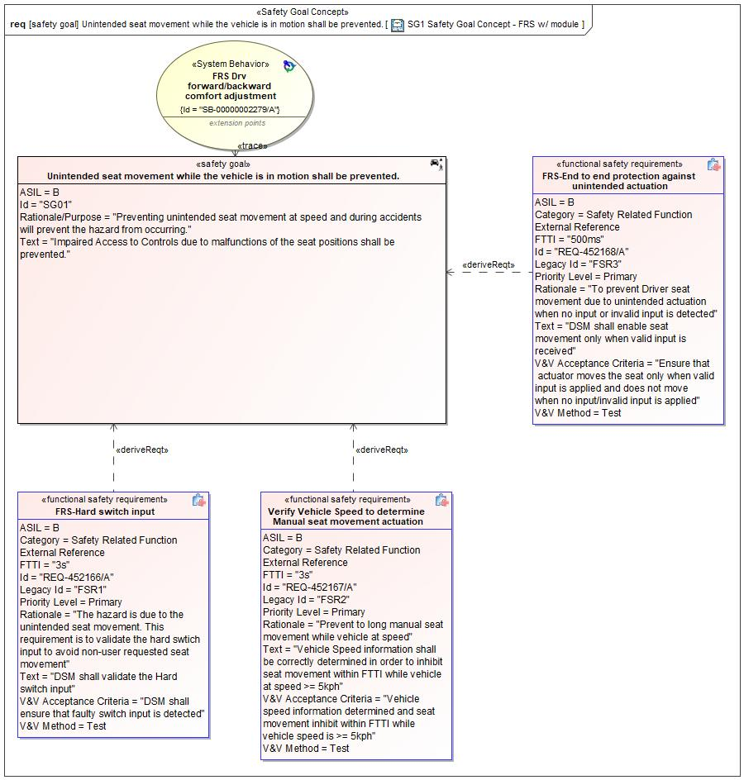

Figure 1: SG1 Safety Goal Concept - FRS w/ module – Unintended seat movement while the vehicle is in motion shall be prevented.

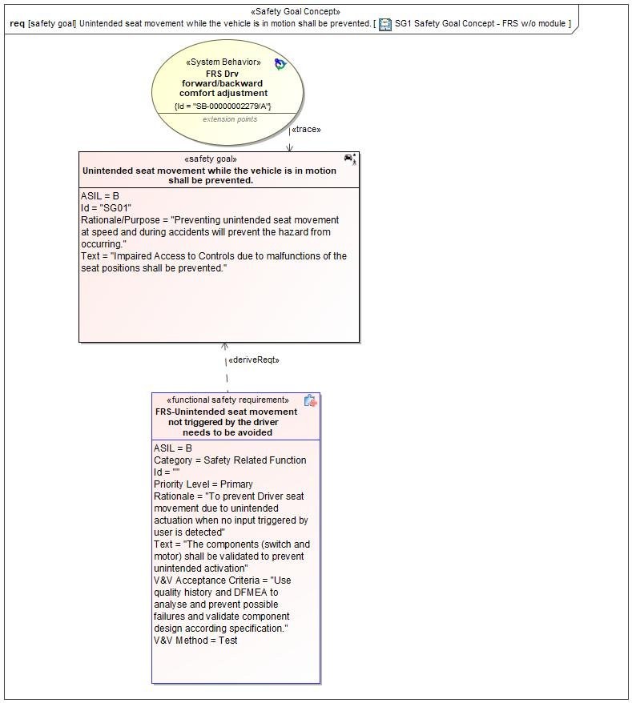

Figure 1: SG1 Safety Goal Concept - FRS w/o module – Unintended seat movement while the vehicle is in motion shall be prevented.

*Note: The authoritative source for the Safety Goals is document “FFSD 02 Hazard Analysis* *and Risk Assessment”. The documentation of Safety Goals in this chapter (In the Argumentation for Safety Goal achievement) is for information purposes only.*

*The authoritative source for the Functional Safety Requirements is section 2.1.x.3: of this document. The documentation of Functional Safety Requirements in the following chapter (complete or summarised) is for information purposes only.*

#### Warning and Recovery Concept

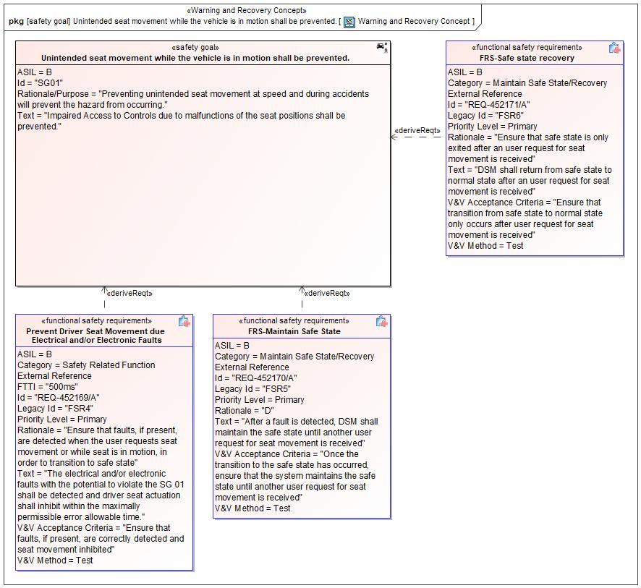

Figure 13: Warning and Recovery Concept – Unintended seat movement while the vehicle is in motion shall be prevented.

#### FSRs for SG01 - Unintended seat movement while the vehicle is in motion shall be prevented.

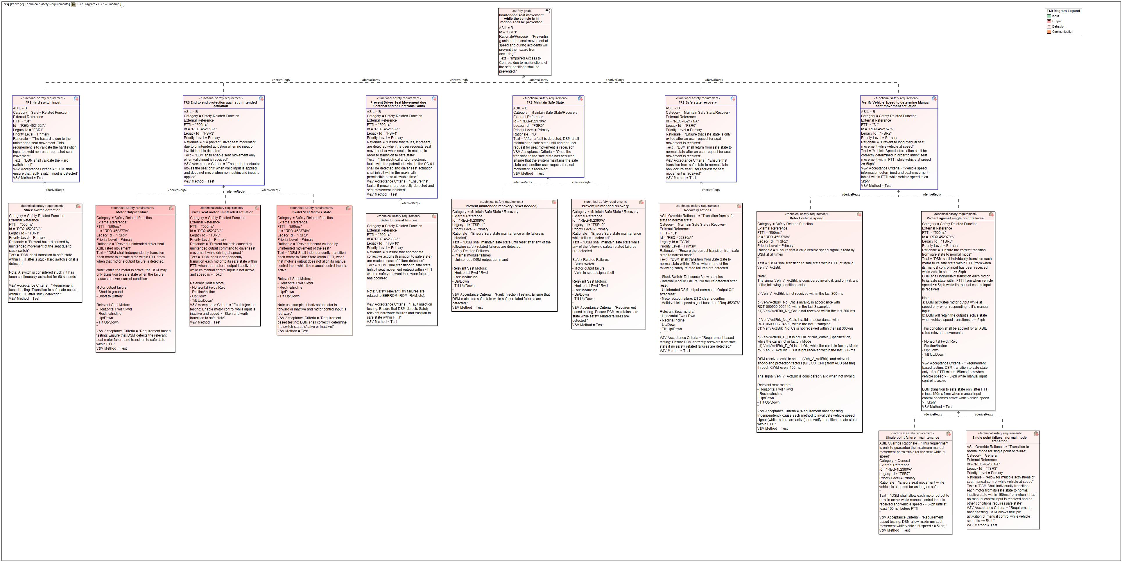

Figure 14. Unintended seat movement while the vehicle is in motion shall be prevented.

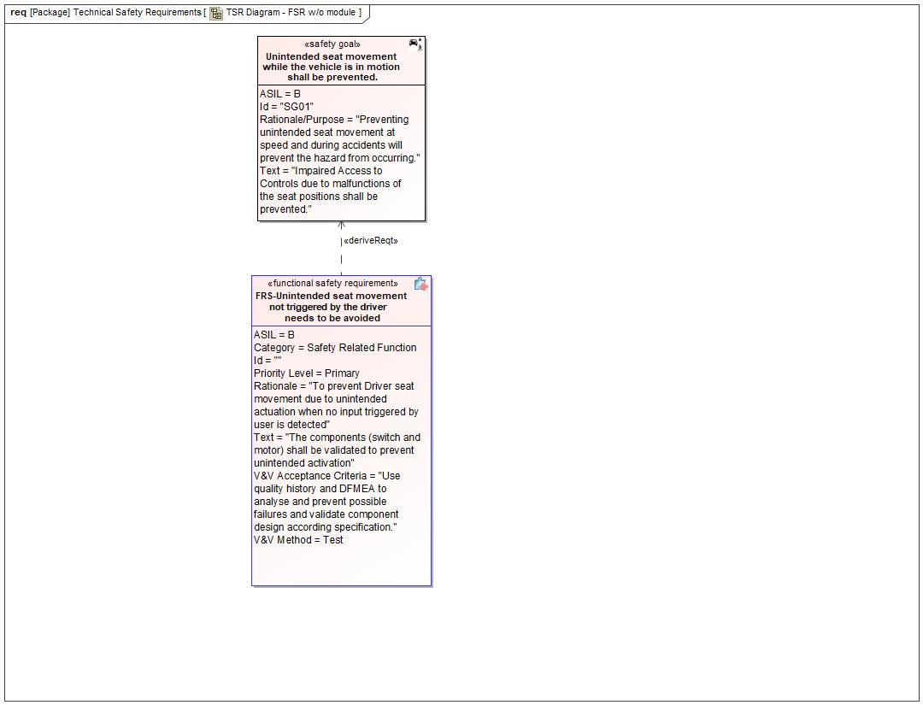

Figure 15. Unintended seat movement while the vehicle is in motion shall be prevented.

FRS-Unintended seat movement not triggered by the driver needs to be avoided

The components (switch and motor) shall be validated to prevent unintended activation

|  |  |  |  |  |  |  |  |
| --- | --- | --- | --- | --- | --- | --- | --- |
| Requirement ID: | | | | | | | |
| **Purpose** |  | | | | | | |
| **V&V Acceptance Criteria** | Use quality history and DFMEA to analyse and prevent possible failures and validate component design according specification. | | | | | | |
| **Notes** |  | | | | | | |
| **Source** |  | | | | | **Owner** |  |
| **Source Req.** | * 27896032.jpg SG01 Unintended seat movement while the vehicle is in motion shall be prevented. | | | | | **V&V Method** | Test |
| **Type** | N/A | | **Priority** | | N/A | **Status** | In-Progress |
| **ASIL** | B | | **Category** | | Safety Related Function | **Fault Handling Time** | N/A |
| [Req. Template](http://wiki.ford.com/display/RequirementsEngineering/Requirements+Attributes) Version | | 6.0 | | End of Requirement | | | |

REQ-452166/A FRS-Hard switch input

DSM shall validate the Hard switch input

Satisfied by:

* Logicals:
  + Front Driver Seat System
  + FRS Driver Comfort System
  + FRS Driver Cushion Tilt Actuator
  + FRS Driver ForeAft Actuator
  + FRS Driver InclineRecline Actuator
  + FRS Driver Seat Height Actuator

Related to:

* Safe States:
  + Seat movement inhibited
* Operating Modes:
  + Manual Comfort Adjustment

|  |  |  |  |  |  |  |  |
| --- | --- | --- | --- | --- | --- | --- | --- |
| Requirement ID: REQ-452166/A | | | | | | | |
| **Purpose** |  | | | | | | |
| **V&V Acceptance Criteria** | DSM shall ensure that faulty switch input is detected | | | | | | |
| **Notes** |  | | | | | | |
| **Source** |  | | | | | **Owner** |  |
| **Source Req.** | * 27896032.jpg SG01 Unintended seat movement while the vehicle is in motion shall be prevented. | | | | | **V&V Method** | Test |
| **Type** | N/A | | **Priority** | | N/A | **Status** | In-Progress |
| **ASIL** | B | | **Category** | | Safety Related Function | **Fault Handling Time** | N/A |
| [Req. Template](http://wiki.ford.com/display/RequirementsEngineering/Requirements+Attributes) Version | | 6.0 | | End of Requirement | | | |

REQ-452167/A Verify Vehicle Speed to determine Manual seat movement actuation

Vehicle Speed information shall be correctly determined in order to inhibit seat movement within FTTI while vehicle at speed >= 5kph

Satisfied by:

* Logicals:
  + Front Driver Seat System
  + FRS Driver Comfort System
  + FRS Driver Cushion Tilt Actuator
  + FRS Driver ForeAft Actuator
  + FRS Driver InclineRecline Actuator
  + FRS Driver Seat Height Actuator

Related to:

* Safe States:
  + Seat movement inhibited
* Operating Modes:
  + Normal

|  |  |  |  |  |  |  |  |
| --- | --- | --- | --- | --- | --- | --- | --- |
| Requirement ID: REQ-452167/A | | | | | | | |
| **Purpose** |  | | | | | | |
| **V&V Acceptance Criteria** | Vehicle speed information determined and seat movement inhibit within FTTI while vehicle speed is >= 5kph | | | | | | |
| **Notes** |  | | | | | | |
| **Source** |  | | | | | **Owner** |  |
| **Source Req.** | * 27896032.jpg SG01 Unintended seat movement while the vehicle is in motion shall be prevented. | | | | | **V&V Method** | Test |
| **Type** | N/A | | **Priority** | | N/A | **Status** | In-Progress |
| **ASIL** | B | | **Category** | | Safety Related Function | **Fault Handling Time** | N/A |
| [Req. Template](http://wiki.ford.com/display/RequirementsEngineering/Requirements+Attributes) Version | | 6.0 | | End of Requirement | | | |

REQ-452168/A FRS-End to end protection against unintended actuation

DSM shall enable seat movement only when valid input is received

Satisfied by:

* Logicals:
  + FRS Driver Cushion Tilt Actuator
  + FRS Driver ForeAft Actuator
  + FRS Driver InclineRecline Actuator
  + FRS Driver Seat Height Actuator

Related to:

* Safe States:
  + Seat movement inhibited
* Operating Modes:
  + Manual Comfort Adjustment

|  |  |  |  |  |  |  |  |
| --- | --- | --- | --- | --- | --- | --- | --- |
| Requirement ID: REQ-452168/A | | | | | | | |
| **Purpose** |  | | | | | | |
| **V&V Acceptance Criteria** | Ensure that actuator moves the seat only when valid input is applied and does not move when no input/invalid input is applied | | | | | | |
| **Notes** |  | | | | | | |
| **Source** |  | | | | | **Owner** |  |
| **Source Req.** | * 27896032.jpg SG01 Unintended seat movement while the vehicle is in motion shall be prevented. | | | | | **V&V Method** | Test |
| **Type** | N/A | | **Priority** | | N/A | **Status** | In-Progress |
| **ASIL** | B | | **Category** | | Safety Related Function | **Fault Handling Time** | N/A |
| [Req. Template](http://wiki.ford.com/display/RequirementsEngineering/Requirements+Attributes) Version | | 6.0 | | End of Requirement | | | |

REQ-452169/A Prevent Driver Seat Movement due Electrical and/or Electronic Faults

The electrical and/or electronic faults with the potential to violate the SG 01 shall be detected and driver seat actuation shall inhibit within the maximally permissible error allowable time.

Satisfied by:

* Logicals:
  + Front Driver Seat System
  + FRS Driver Comfort System

Related to:

* Safe States:
  + Seat movement inhibited
* Operating Modes:
  + Normal

|  |  |  |  |  |  |  |  |
| --- | --- | --- | --- | --- | --- | --- | --- |
| Requirement ID: REQ-452169/A | | | | | | | |
| **Purpose** |  | | | | | | |
| **V&V Acceptance Criteria** | Ensure that faults, if present, are correctly detected and seat movement inhibited | | | | | | |
| **Notes** |  | | | | | | |
| **Source** |  | | | | | **Owner** |  |
| **Source Req.** | * 27896032.jpg SG01 Unintended seat movement while the vehicle is in motion shall be prevented. | | | | | **V&V Method** | Test |
| **Type** | N/A | | **Priority** | | N/A | **Status** | In-Progress |
| **ASIL** | B | | **Category** | | Safety Related Function | **Fault Handling Time** | N/A |
| [Req. Template](http://wiki.ford.com/display/RequirementsEngineering/Requirements+Attributes) Version | | 6.0 | | End of Requirement | | | |

REQ-452170/A FRS-Maintain Safe State

After a fault is detected, DSM shall maintain the safe state until another user request for seat movement is received

Satisfied by:

* Logicals:
  + Front Driver Seat System

Related to:

* Safe States:
  + Seat movement inhibited
* Operating Modes:
  + Seat movement inhibited

|  |  |  |  |  |  |  |  |
| --- | --- | --- | --- | --- | --- | --- | --- |
| Requirement ID: REQ-452170/A | | | | | | | |
| **Purpose** |  | | | | | | |
| **V&V Acceptance Criteria** | Once the transition to the safe state has occurred, ensure that the system maintains the safe state until another user request for seat movement is received | | | | | | |
| **Notes** |  | | | | | | |
| **Source** |  | | | | | **Owner** |  |
| **Source Req.** | * 27896032.jpg SG01 Unintended seat movement while the vehicle is in motion shall be prevented. | | | | | **V&V Method** | Test |
| **Type** | N/A | | **Priority** | | N/A | **Status** | In-Progress |
| **ASIL** | B | | **Category** | | Maintain Safe State/Recovery | **Fault Handling Time** | N/A |
| [Req. Template](http://wiki.ford.com/display/RequirementsEngineering/Requirements+Attributes) Version | | 6.0 | | End of Requirement | | | |

REQ-452171/A FRS-Safe state recovery

DSM shall return from safe state to normal state after an user request for seat movement is received

Satisfied by:

* Logicals:
  + Front Driver Seat System

Related to:

* Safe States:
  + Seat movement inhibited
* Operating Modes:
  + Seat movement inhibited

|  |  |  |  |  |  |  |  |
| --- | --- | --- | --- | --- | --- | --- | --- |
| Requirement ID: REQ-452171/A | | | | | | | |
| **Purpose** |  | | | | | | |
| **V&V Acceptance Criteria** | Ensure that transition from safe state to normal state only occurs after user request for seat movement is received | | | | | | |
| **Notes** |  | | | | | | |
| **Source** |  | | | | | **Owner** |  |
| **Source Req.** | * 27896032.jpg SG01 Unintended seat movement while the vehicle is in motion shall be prevented. | | | | | **V&V Method** | Test |
| **Type** | N/A | | **Priority** | | N/A | **Status** | In-Progress |
| **ASIL** | B | | **Category** | | Maintain Safe State/Recovery | **Fault Handling Time** | N/A |
| [Req. Template](http://wiki.ford.com/display/RequirementsEngineering/Requirements+Attributes) Version | | 6.0 | | End of Requirement | | | |

### Derivation of Functional Safety Requirements on Assumptions

No Functional Safety Requirements tracing to Assumptions specified.

### ASIL Decomposition of Functional Safety Requirements

No Functional Safety Requirements with ASIL Decompositions specified.

# CyberSecurity

## Security Goals

|  |  |
| --- | --- |
| ID | Goal |

Table 14: Cybersecurity Goals

## Cybersecurity Requirements

# Architecture

## Functional Decomposition

Diagram showing object flows for the supervised and unsupervised movement of the first row seats



Figure 16: Control 1st Row Seat Comfort Positions

This activity diagram outlines the concept level object flows to support SRS power pitch/slide



Figure 17: Control FRS Position to Support SRS Power Pitch/Slide

Concept level activity diagram for FRS learn cycle



Figure 18: Learn 1st Row Seat Configuration Settings

Activity diagram to show the object flows needed to support easy entry/exit for the FRS Driver's seat



Figure 19: Provide Easy Entry/Exit

### Functions

| **Function Name** | Description | Comments |
| --- | --- | --- |
| *(activity)* Request Manual FRS Comfort Adjustments | *(activity)* The "Request Manual FRS Comfort Adjustments" Domain Function represents the request for FRS comfort adjustments for both the driver and the passenger due to manual selection made by the "Supervised Seat Movement Requestor". |  |
| *(activity)* Provide Vehicle Speed and Transmission Status |  |  |
| *(activity)* Receive Comfort Adjustment Status |  |  |
| *(activity)* Provide SRS Pitched Position |  |  |
| *(activity)* Perceive Passenger Seat Movement |  |  |
| *(activity)* Control Automated Adjustments for FRS Comfort Positions | *(activity)* The "Control Automated Adjustments for FRS Comfort Positions" Feature Function will control the automated FRS comfort adjustments to the seat position requested by the "Unsupervised Seat Movement Requestor". |  |
| *(activity)* Set FRS Memory Position | *(activity)* The "Set FRS Memory Position" Domain Function represents the storing of the FRS Comfort Positions for both the driver and passenger. |  |
| *(activity)* Control Manual Adjustments for FRS Comfort Positions | *(activity)* The "Control Manual Adjustments for FRS Comfort Positions" Feature Function will control the FRS comfort adjustments for both the first row driver and passenger as requested by the "Supervised Seat Movement Requestor". It will also provide the FRS position for memory storage. |  |
| *(activity)* Perceive Driver Seat Movement | *(activity)* The Driver and/or Passenger perceives the changing position of the FRS. |  |
| *(activity)* Request Unsupervised FRS Comfort Adjustments | *(activity)* The "Request Unsupervised FRS Comfort Adjustments" Domain Function represents the externally request for automated FRS comfort adjustments for the driver and passenger seats. |  |

Table 15: List of Functions on Control 1st Row Seat Comfort Positions

| **Function Name** | Description | Comments |
| --- | --- | --- |
| *(activity)* Request FRS Adjustment for Pitch/Slide Enablement | *(activity)* The "Request FRS Adjustment for Pitch/Slide Enablement" Domain Function represents the "SRS Manager" request to the FRS System to move to the "Enabled" Position in order to enable SRS Power Pitch/Slide. |  |
| *(activity)* Receive FRS Pitch/Slide Position Status | *(activity)* The "Receive FRS Pitch/Slide Position Status" Domain Function receives the position status of the First Row Seat to enable SRS Power Pitch/Slide. |  |
| *(activity)* Provide 1st Row Seat Movement for Power Pitch/Slide | *(activity)* The "Provide 1st Row Seat Movement for Power Pitch/Slide" Feature Function will move the First Row Seat as requested by the "SRS Manager" and provide its position for Second Row Seat Pitch/Slide. |  |
| *(activity)* Provide Vehicle Speed and Transmission Status |  |  |
| *(activity)* Perceive Passenger Seat Movement |  |  |
| *(activity)* Perceive Driver Seat Movement | *(activity)* The Driver and/or Passenger perceives the changing position of the FRS. |  |

Table 16: List of Functions on Control FRS Position to Support SRS Power Pitch/Slide

| **Function Name** | Description | Comments |
| --- | --- | --- |
| *(activity)* Perceive Passenger Seat Movement |  |  |
| *(activity)* Request to Set FRS Configuration Parameters | *(activity)* The "Request to Set FRS Configuration Parameters" Domain Function will request for the Learn Cycle process to be initiated for the driver and/or passenger FRS and provide the sequence profile through which the FRS System will perform the learn cycle. |  |
| *(activity)* Run Configuration Process | *(activity)* The "Run Configuration Process" Feature Function represents the Learn Cycle process to configure the end-points for the driver and passenger 1st row seats. |  |
| *(activity)* Perceive Driver Seat Movement | *(activity)* The Driver and/or Passenger perceives the changing position of the FRS. |  |

Table 17: List of Functions on Learn 1st Row Seat Configuration Settings

| **Function Name** | Description | Comments |
| --- | --- | --- |
| *(activity)* Provide Easy Entry and Exit Seat Movement | *(activity)* The "Provide Easy Entry and Exit" Feature Function controls the moving of the front row driver's seat for easy entry/exit as well as requesting the steering column to move. |  |
| *(activity)* Perceive Driver Seat Movement | *(activity)* The Driver and/or Passenger perceives the changing position of the FRS. |  |
| *(activity)* Provide Vehicle Speed and Transmission Status |  |  |
| *(activity)* Request Easy Entry/Exit | *(activity)* The "Request Easy Entry/Exit" Domain Function is the Memory Seat Manager request for the driver FRS adjustments for Easy Entry and Exit. |  |

Table 18: List of Functions on Provide Easy Entry/Exit

## Logical Architecture

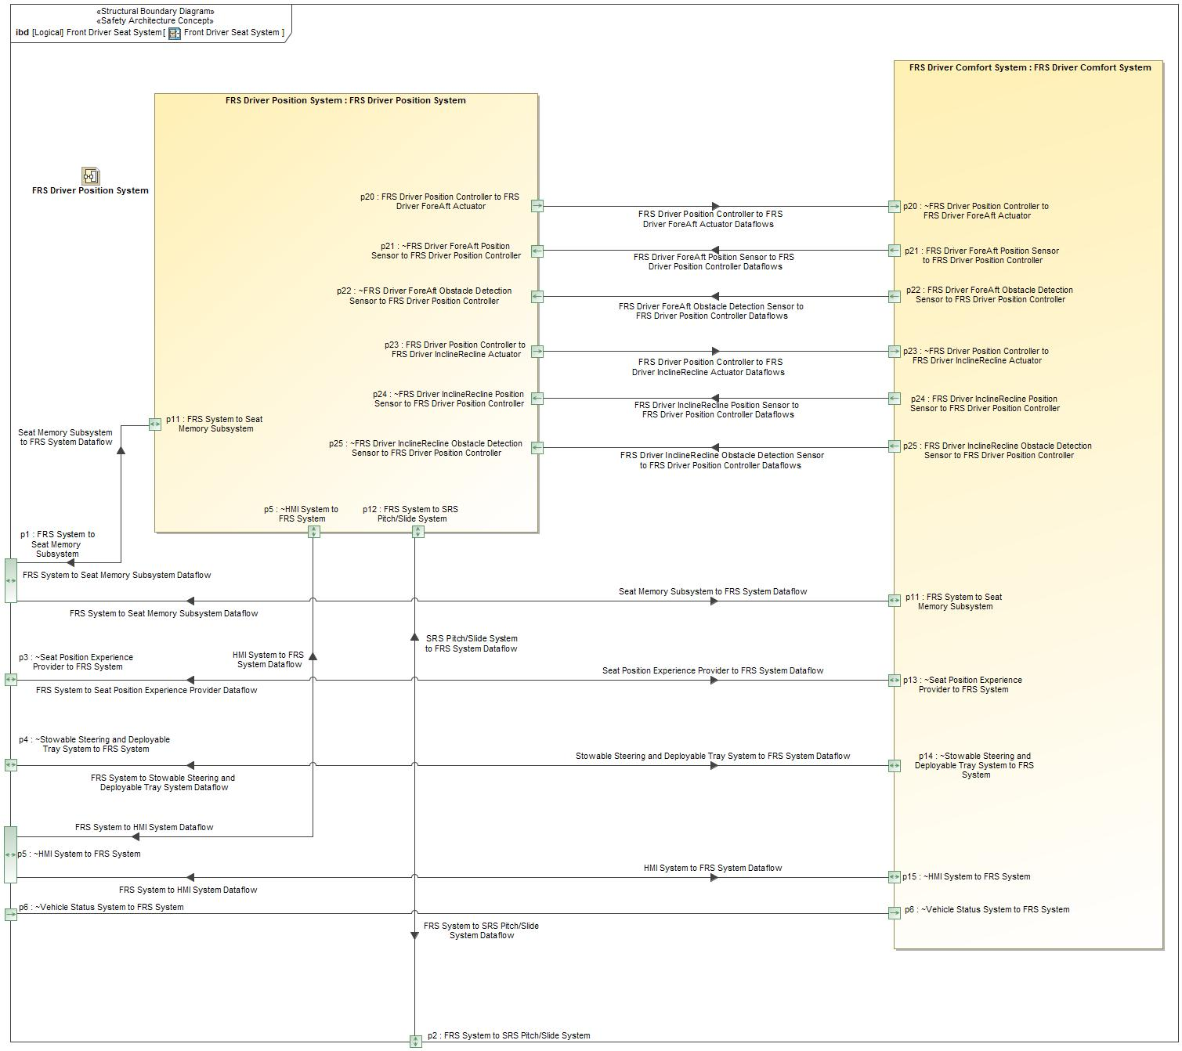

Figure 20: Front Driver Seat System

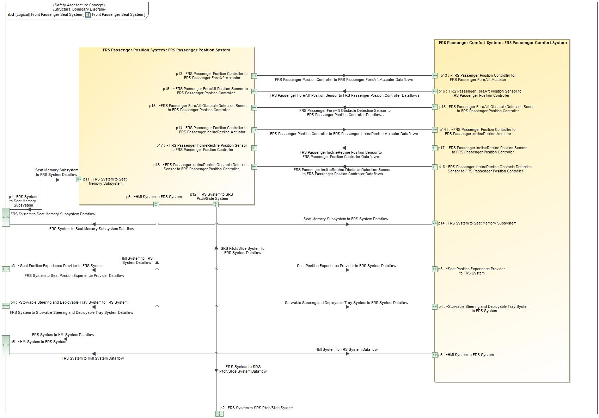

Figure 21: Front Passenger Seat System

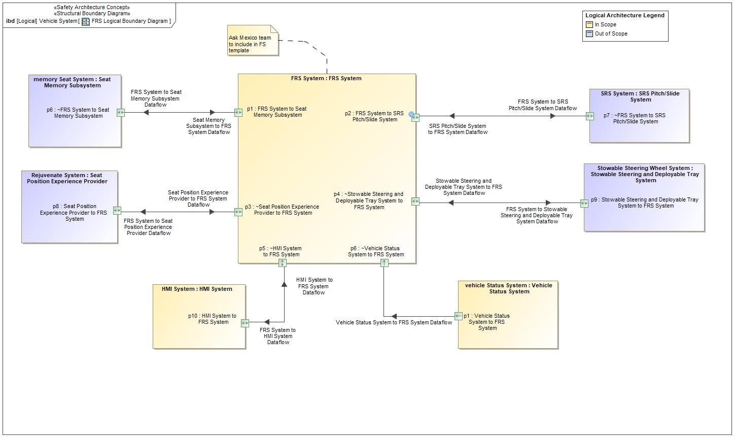

Figure 22: FRS Logical Boundary Diagram

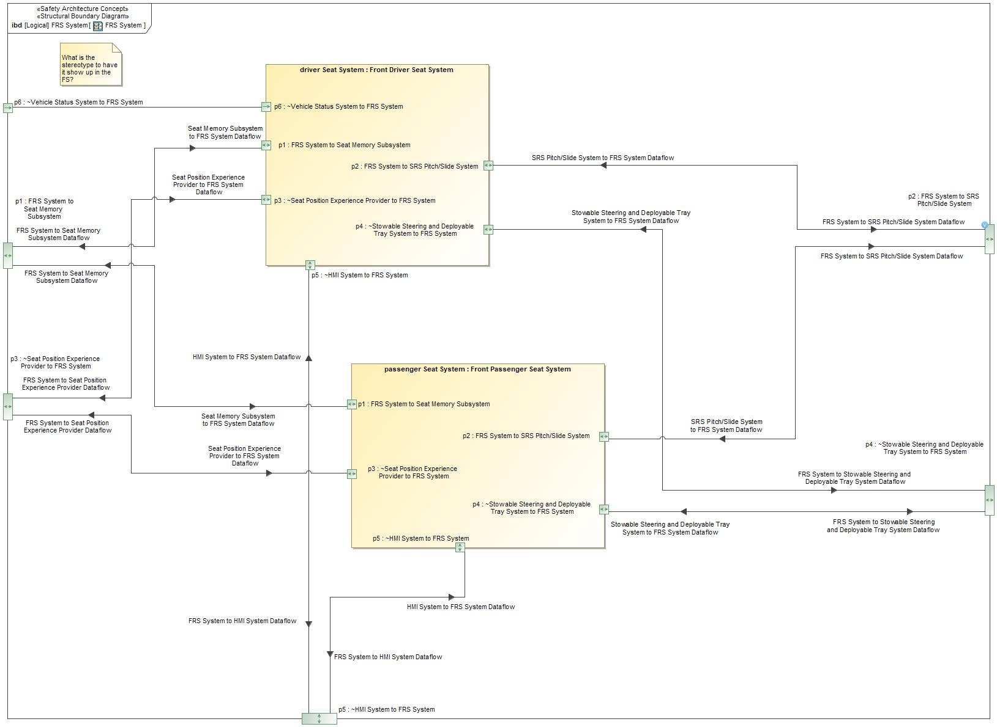

Figure 23: FRS System

### Logical Elements

| **Element Name** | **Description** | **Allocated Functions** | **Comments** |
| --- | --- | --- | --- |
|  |  |  |  |
| Front Driver Seat System | Represents the First Row Seat Driver's Seat System. The system is composed of the FRS Driver Position System and FRS Driver Comfort System. |  |  |
| Front Passenger Seat System | Represents the First Row Seat Passenger's Seat System. The system is composed of the FRS Passenger Position System and FRS Passenger Comfort System. | * Control 1st Row Seat Passenger Comfort Positions |  |
| FRS Driver Comfort System | Represents the First Row Seat Driver's Comfort System. | * System Function * Move Driver Seat to Externally Requested Position * Control 1st Row Seat Driver Comfort Positions * Actuate and Sense for Driver Power Pitch/Slide * Actuate and Sense for Easy Entry Exit * Set Driver Seat Position Configurations * Report Driver FRS Learn Cycle Completion Status * Set Passenger Seat Position Configurations * Report Passenger FRS Learn Cycle Completion Status |  |
| FRS Driver Position System | Represents the First Row Seat Driver's Position System. | * Control Driver FRS for SRS Pitch/Slide * Control Seat Position for Easy Entry and Exit |  |
| FRS Passenger Comfort System | Represents the First Row Seat Passenger's Comfort System. | * Move Passenger Seat to Externally Requested Position * Actuate and Sense for Passenger Power Pitch/Slide * Set Passenger Seat Position Configurations * Report Passenger FRS Learn Cycle Completion Status |  |
| FRS Passenger Position System | Represents the First Row Seat Passenger's Position System. | * Control Passenger FRS for SRS Pitch/Slide |  |
| FRS System | Represents the logical system of the First Row Seat feature. The system composes of the Front Driver and Passenger Seat Systems. | * Move Driver Seat to Externally Requested Position * Move Passenger Seat to Externally Requested Position * Control 1st Row Seat Driver Comfort Positions * Control 1st Row Seat Passenger Comfort Positions * Control Driver FRS for SRS Pitch/Slide * Actuate and Sense for Driver Power Pitch/Slide * Control Passenger FRS for SRS Pitch/Slide * Actuate and Sense for Passenger Power Pitch/Slide * Control Seat Position for Easy Entry and Exit * Actuate and Sense for Easy Entry Exit |  |
| HMI System | Represents the Human - Machine Interface System for the First Row Seat Control feature. | * Convey Seat Comfort Adjustment Request * Convey Chauffeur Adjustment Request |  |
| Seat Memory Subsystem | The subsystem within the Classic Memory feature (F000171) that interfaces with the FRS feature to request for automated adjustments. |  |  |
| Seat Position Experience Provider | The portion of the Rejuvenate feature (F003072) that interfaces with the FRS feature to request automated adjustments. |  |  |
| SRS Pitch/Slide System | Represents the Pitch/Slide System of the Second Row Seat Control feature (F003517) that interfaces with the FRS feature. |  |  |
| Stowable Steering and Deployable Tray System | Represents the system of the Stowable Steering Wheel feature (F002870) that interfaces with the FRS feature. |  |  |
| Vehicle Status System |  |  |  |

Table 19: Logical Elements

### Logical Interfaces

| **Interface** | **Direction** | **Description** | **Value Range** |
| --- | --- | --- | --- |
| FRS Driver ForeAft Obstacle Detection Sensor to FRS Driver Position Controller Dataflows | p22 (FRS Driver Comfort System) To p22 (FRS Driver Position System) |  | as ForeAftObstacleStatus:   * OBSTACLE_DETECTED * OBSTACLE_NOT_DETECTED |
| FRS Driver ForeAft Position Sensor to FRS Driver Position Controller Dataflows | p21 (FRS Driver Comfort System) To p21 (FRS Driver Position System) |  | as CurrentPositionForeAft: |
| FRS Driver InclineRecline Obstacle Detection Sensor to FRS Driver Position Controller Dataflows | p25 (FRS Driver Comfort System) To p25 (FRS Driver Position System) |  | as InclineReclineObstacleStatus:   * OBSTACLE_DETECTED * OBSTACLE_NOT_DETECTED |
| FRS Driver InclineRecline Position Sensor to FRS Driver Position Controller Dataflows | p24 (FRS Driver Comfort System) To p24 (FRS Driver Position System) |  | as CurrentPositionInclineRecline: |
| FRS Driver Position Controller to FRS Driver ForeAft Actuator Dataflows | p20 (FRS Driver Position System) To p20 (FRS Driver Comfort System) |  | as ForeAftAdjustment:   * FORWARD * REARWARD * NULL |
| FRS Driver Position Controller to FRS Driver InclineRecline Actuator Dataflows | p23 (FRS Driver Position System) To p23 (FRS Driver Comfort System) |  | as InclineReclineAdjustment:   * FORWARD * REARWARD * NULL |
| FRS System to HMI System Dataflow | p5 (FRS Driver Position System) To p5 (Front Driver Seat System) |  | LearningRequest_SeatID  as SeatID:   * DRIVER * PASSENGER * DRIVER_MEMORY * PASSENGER_MEMORY   DriverFRSLearningStatus  as LearnCycleStatus:  PassengerFRSLearningStatus  as LearnCycleStatus: |
| p15 (FRS Driver Comfort System) To p5 (Front Driver Seat System) |  | LearningRequest_SeatID  as SeatID:   * DRIVER * PASSENGER * DRIVER_MEMORY * PASSENGER_MEMORY   DriverFRSLearningStatus  as LearnCycleStatus:  PassengerFRSLearningStatus  as LearnCycleStatus: |
| FRS System to Seat Memory Subsystem Dataflow | p11 (FRS Driver Comfort System) To p1 (Front Driver Seat System) |  | MemoryRequest_SeatID  as SeatID:   * DRIVER * PASSENGER * DRIVER_MEMORY * PASSENGER_MEMORY   as Profile_Settings:   * Rejuvenate * StowableSteeringWheel * MEMORY_SEAT1 * MEMORY_SEAT2 |
| p11 (FRS Driver Position System) To p1 (Front Driver Seat System) |  | MemoryRequest_SeatID  as SeatID:   * DRIVER * PASSENGER * DRIVER_MEMORY * PASSENGER_MEMORY   as Profile_Settings:   * Rejuvenate * StowableSteeringWheel * MEMORY_SEAT1 * MEMORY_SEAT2 |
| FRS System to Seat Position Experience Provider Dataflow | p13 (FRS Driver Comfort System) To p3 (Front Driver Seat System) |  | Driver Seat Movement  as UserPerceivedSeatMovement:  Passenger Seat Movement  as UserPerceivedSeatMovement: |
| FRS System to SRS Pitch/Slide System Dataflow | p12 (FRS Driver Position System) To p2 (Front Driver Seat System) |  | Drv_DistancetoEnabledPosition  as DistanceToEnabled:  Drv_TimetoEnabledPosition  as TimeToEnabledPosition:  Drv_ElapsedTime  as ElapsedTime:  Pass_DistancetoEnabledPosition  as DistanceToEnabled:  Pass_TimetoEnabledPosition  as TimeToEnabledPosition:  Pass_ElapsedTime  as ElapsedTime: |
| FRS System to Stowable Steering and Deployable Tray System Dataflow | p14 (FRS Driver Comfort System) To p4 (Front Driver Seat System) |  | Driver Seat Movement  as UserPerceivedSeatMovement:  Passenger Seat Movement  as UserPerceivedSeatMovement: |
| HMI System to FRS System Dataflow | p5 (Front Driver Seat System) To p5 (FRS Driver Position System) |  | as ComfortSettings:  ComfortRequest_SeatID  as SeatID:   * DRIVER * PASSENGER * DRIVER_MEMORY * PASSENGER_MEMORY   as FRS_ChauffeurAdjustment:   * CHAUFFEUR_RECLINE_FORWARD * CHAUFFEUR_SLIDE_SEAT_FORWARD * CHAUFFEUR_RECLINE_REARWARD * CHAUFFEUR_SLIDE_SEAT_REARWARD * NULL |
| p5 (Front Driver Seat System) To p15 (FRS Driver Comfort System) |  | as ComfortSettings:  ComfortRequest_SeatID  as SeatID:   * DRIVER * PASSENGER * DRIVER_MEMORY * PASSENGER_MEMORY   as FRS_ChauffeurAdjustment:   * CHAUFFEUR_RECLINE_FORWARD * CHAUFFEUR_SLIDE_SEAT_FORWARD * CHAUFFEUR_RECLINE_REARWARD * CHAUFFEUR_SLIDE_SEAT_REARWARD * NULL |
| Seat Memory Subsystem to FRS System Dataflow | p1 (Front Driver Seat System) To p11 (FRS Driver Comfort System) |  | Driver Seat Movement  as UserPerceivedSeatMovement:  Passenger Seat Movement  as UserPerceivedSeatMovement:  as EasyEntryExitRequest:   * RESTORE_DRIVE_POSITION * EASY_ENTRY_EXIT * NULL |
| p1 (Front Driver Seat System) To p11 (FRS Driver Position System) |  | Driver Seat Movement  as UserPerceivedSeatMovement:  Passenger Seat Movement  as UserPerceivedSeatMovement:  as EasyEntryExitRequest:   * RESTORE_DRIVE_POSITION * EASY_ENTRY_EXIT * NULL |
| Seat Position Experience Provider to FRS System Dataflow | p3 (Front Driver Seat System) To p13 (FRS Driver Comfort System) |  | MemoryRequest_SeatID  as SeatID:   * DRIVER * PASSENGER * DRIVER_MEMORY * PASSENGER_MEMORY   as Profile_Settings:   * Rejuvenate * StowableSteeringWheel * MEMORY_SEAT1 * MEMORY_SEAT2 |
| SRS Pitch/Slide System to FRS System Dataflow | p2 (Front Driver Seat System) To p12 (FRS Driver Position System) |  | Drv_PowerPitchSlideRequest  as DriverFRS_PPSEEE_Request:   * MOVE_DRIVER_FORWARD * RESET_DRIVER * DO_NOT_MOVE   Pass_PowerPitchSlideRequest  as PassengerFRS_PPSEEE_Request:   * MOVE_PASSENGER_FORWARD * RESET_PASSENGER * DO_NOT_MOVE   Drv_side_SRSPitchSlidePosition  as SRSPitchSlidePosition_Driver:  Pass_side_SRSPitchSlidePosition  as SRSPitchSlidePosition_Passenger: |
| Stowable Steering and Deployable Tray System to FRS System Dataflow | p4 (Front Driver Seat System) To p14 (FRS Driver Comfort System) |  | MemoryRequest_SeatID  as SeatID:   * DRIVER * PASSENGER * DRIVER_MEMORY * PASSENGER_MEMORY   as Profile_Settings:   * Rejuvenate * StowableSteeringWheel * MEMORY_SEAT1 * MEMORY_SEAT2 |

Table 20: Feature Interactions on Front Driver Seat System

| **Interface** | **Direction** | **Description** | **Value Range** |
| --- | --- | --- | --- |
| FRS Passenger ForeAft Position Sensor to FRS Passenger Position Controller Dataflows | p16 (FRS Passenger Comfort System) To p16 (FRS Passenger Position System) |  | as CurrentPositionForeAft: |
| FRS Passenger InclineRecline Position Sensor to FRS Passenger Position Controller Dataflows | p17 (FRS Passenger Comfort System) To p17 (FRS Passenger Position System) |  | as CurrentPositionInclineRecline: |
| FRS Passenger ForeAft Obstacle Detection Sensor to FRS Passenger Position Controller Dataflows | p15 (FRS Passenger Comfort System) To p15 (FRS Passenger Position System) |  | as ForeAftObstacleStatus:   * OBSTACLE_DETECTED * OBSTACLE_NOT_DETECTED |
| FRS Passenger InclineRecline Obstacle Detection Sensor to FRS Passenger Position Controller Dataflows | p18 (FRS Passenger Comfort System) To p18 (FRS Passenger Position System) |  | as InclineReclineObstacleStatus:   * OBSTACLE_DETECTED * OBSTACLE_NOT_DETECTED |
| FRS Passenger Position Controller to FRS Passenger ForeAft Actuator Dataflows | p13 (FRS Passenger Position System) To p13 (FRS Passenger Comfort System) |  | as ForeAftAdjustment:   * FORWARD * REARWARD * NULL |
| FRS Passenger Position Controller to FRS Passenger InclineRecline Actuator Dataflows | p14 (FRS Passenger Position System) To p141 (FRS Passenger Comfort System) |  | as InclineReclineAdjustment:   * FORWARD * REARWARD * NULL |
| FRS System to HMI System Dataflow | p5 (FRS Passenger Comfort System) To p5 (Front Passenger Seat System) |  | LearningRequest_SeatID  as SeatID:   * DRIVER * PASSENGER * DRIVER_MEMORY * PASSENGER_MEMORY   DriverFRSLearningStatus  as LearnCycleStatus:  PassengerFRSLearningStatus  as LearnCycleStatus: |
| p5 (FRS Passenger Position System) To p5 (Front Passenger Seat System) |  | LearningRequest_SeatID  as SeatID:   * DRIVER * PASSENGER * DRIVER_MEMORY * PASSENGER_MEMORY   DriverFRSLearningStatus  as LearnCycleStatus:  PassengerFRSLearningStatus  as LearnCycleStatus: |
| FRS System to Seat Memory Subsystem Dataflow | p11 (FRS Passenger Position System) To p1 (Front Passenger Seat System) |  | MemoryRequest_SeatID  as SeatID:   * DRIVER * PASSENGER * DRIVER_MEMORY * PASSENGER_MEMORY   as Profile_Settings:   * Rejuvenate * StowableSteeringWheel * MEMORY_SEAT1 * MEMORY_SEAT2 |
| p14 (FRS Passenger Comfort System) To p1 (Front Passenger Seat System) |  | MemoryRequest_SeatID  as SeatID:   * DRIVER * PASSENGER * DRIVER_MEMORY * PASSENGER_MEMORY   as Profile_Settings:   * Rejuvenate * StowableSteeringWheel * MEMORY_SEAT1 * MEMORY_SEAT2 |
| FRS System to Seat Position Experience Provider Dataflow | p3 (FRS Passenger Comfort System) To p3 (Front Passenger Seat System) |  | Driver Seat Movement  as UserPerceivedSeatMovement:  Passenger Seat Movement  as UserPerceivedSeatMovement: |
| FRS System to SRS Pitch/Slide System Dataflow | p12 (FRS Passenger Position System) To p2 (Front Passenger Seat System) |  | Drv_DistancetoEnabledPosition  as DistanceToEnabled:  Drv_TimetoEnabledPosition  as TimeToEnabledPosition:  Drv_ElapsedTime  as ElapsedTime:  Pass_DistancetoEnabledPosition  as DistanceToEnabled:  Pass_TimetoEnabledPosition  as TimeToEnabledPosition:  Pass_ElapsedTime  as ElapsedTime: |
| FRS System to Stowable Steering and Deployable Tray System Dataflow | p4 (FRS Passenger Comfort System) To p4 (Front Passenger Seat System) |  | Driver Seat Movement  as UserPerceivedSeatMovement:  Passenger Seat Movement  as UserPerceivedSeatMovement: |
| HMI System to FRS System Dataflow | p5 (Front Passenger Seat System) To p5 (FRS Passenger Comfort System) |  | as ComfortSettings:  ComfortRequest_SeatID  as SeatID:   * DRIVER * PASSENGER * DRIVER_MEMORY * PASSENGER_MEMORY   as FRS_ChauffeurAdjustment:   * CHAUFFEUR_RECLINE_FORWARD * CHAUFFEUR_SLIDE_SEAT_FORWARD * CHAUFFEUR_RECLINE_REARWARD * CHAUFFEUR_SLIDE_SEAT_REARWARD * NULL |
| p5 (Front Passenger Seat System) To p5 (FRS Passenger Position System) |  | as ComfortSettings:  ComfortRequest_SeatID  as SeatID:   * DRIVER * PASSENGER * DRIVER_MEMORY * PASSENGER_MEMORY   as FRS_ChauffeurAdjustment:   * CHAUFFEUR_RECLINE_FORWARD * CHAUFFEUR_SLIDE_SEAT_FORWARD * CHAUFFEUR_RECLINE_REARWARD * CHAUFFEUR_SLIDE_SEAT_REARWARD * NULL |
| Seat Memory Subsystem to FRS System Dataflow | p1 (Front Passenger Seat System) To p11 (FRS Passenger Position System) |  | Driver Seat Movement  as UserPerceivedSeatMovement:  Passenger Seat Movement  as UserPerceivedSeatMovement:  as EasyEntryExitRequest:   * RESTORE_DRIVE_POSITION * EASY_ENTRY_EXIT * NULL |
| p1 (Front Passenger Seat System) To p14 (FRS Passenger Comfort System) |  | Driver Seat Movement  as UserPerceivedSeatMovement:  Passenger Seat Movement  as UserPerceivedSeatMovement:  as EasyEntryExitRequest:   * RESTORE_DRIVE_POSITION * EASY_ENTRY_EXIT * NULL |
| Seat Position Experience Provider to FRS System Dataflow | p3 (Front Passenger Seat System) To p3 (FRS Passenger Comfort System) |  | MemoryRequest_SeatID  as SeatID:   * DRIVER * PASSENGER * DRIVER_MEMORY * PASSENGER_MEMORY   as Profile_Settings:   * Rejuvenate * StowableSteeringWheel * MEMORY_SEAT1 * MEMORY_SEAT2 |
| SRS Pitch/Slide System to FRS System Dataflow | p2 (Front Passenger Seat System) To p12 (FRS Passenger Position System) |  | Drv_PowerPitchSlideRequest  as DriverFRS_PPSEEE_Request:   * MOVE_DRIVER_FORWARD * RESET_DRIVER * DO_NOT_MOVE   Pass_PowerPitchSlideRequest  as PassengerFRS_PPSEEE_Request:   * MOVE_PASSENGER_FORWARD * RESET_PASSENGER * DO_NOT_MOVE   Drv_side_SRSPitchSlidePosition  as SRSPitchSlidePosition_Driver:  Pass_side_SRSPitchSlidePosition  as SRSPitchSlidePosition_Passenger: |
| Stowable Steering and Deployable Tray System to FRS System Dataflow | p4 (Front Passenger Seat System) To p4 (FRS Passenger Comfort System) |  | MemoryRequest_SeatID  as SeatID:   * DRIVER * PASSENGER * DRIVER_MEMORY * PASSENGER_MEMORY   as Profile_Settings:   * Rejuvenate * StowableSteeringWheel * MEMORY_SEAT1 * MEMORY_SEAT2 |

Table 21: Feature Interactions on Front Passenger Seat System

| **Interface** | **Direction** | **Description** | **Value Range** |
| --- | --- | --- | --- |
| FRS System to HMI System Dataflow | p5 (FRS System) To p10 (HMI System) |  | LearningRequest_SeatID  as SeatID:   * DRIVER * PASSENGER * DRIVER_MEMORY * PASSENGER_MEMORY   DriverFRSLearningStatus  as LearnCycleStatus:  PassengerFRSLearningStatus  as LearnCycleStatus: |
| FRS System to Seat Memory Subsystem Dataflow | p1 (FRS System) To p6 (Seat Memory Subsystem) |  | MemoryRequest_SeatID  as SeatID:   * DRIVER * PASSENGER * DRIVER_MEMORY * PASSENGER_MEMORY   as Profile_Settings:   * Rejuvenate * StowableSteeringWheel * MEMORY_SEAT1 * MEMORY_SEAT2 |
| FRS System to Seat Position Experience Provider Dataflow | p3 (FRS System) To p8 (Seat Position Experience Provider) |  | Driver Seat Movement  as UserPerceivedSeatMovement:  Passenger Seat Movement  as UserPerceivedSeatMovement: |
| FRS System to SRS Pitch/Slide System Dataflow | p2 (FRS System) To p7 (SRS Pitch/Slide System) |  | Drv_DistancetoEnabledPosition  as DistanceToEnabled:  Drv_TimetoEnabledPosition  as TimeToEnabledPosition:  Drv_ElapsedTime  as ElapsedTime:  Pass_DistancetoEnabledPosition  as DistanceToEnabled:  Pass_TimetoEnabledPosition  as TimeToEnabledPosition:  Pass_ElapsedTime  as ElapsedTime: |
| FRS System to Stowable Steering and Deployable Tray System Dataflow | p4 (FRS System) To p9 (Stowable Steering and Deployable Tray System) |  | Driver Seat Movement  as UserPerceivedSeatMovement:  Passenger Seat Movement  as UserPerceivedSeatMovement: |
| HMI System to FRS System Dataflow | p10 (HMI System) To p5 (FRS System) |  | as ComfortSettings:  ComfortRequest_SeatID  as SeatID:   * DRIVER * PASSENGER * DRIVER_MEMORY * PASSENGER_MEMORY   as FRS_ChauffeurAdjustment:   * CHAUFFEUR_RECLINE_FORWARD * CHAUFFEUR_SLIDE_SEAT_FORWARD * CHAUFFEUR_RECLINE_REARWARD * CHAUFFEUR_SLIDE_SEAT_REARWARD * NULL |
| Seat Memory Subsystem to FRS System Dataflow | p6 (Seat Memory Subsystem) To p1 (FRS System) |  | Driver Seat Movement  as UserPerceivedSeatMovement:  Passenger Seat Movement  as UserPerceivedSeatMovement:  as EasyEntryExitRequest:   * RESTORE_DRIVE_POSITION * EASY_ENTRY_EXIT * NULL |
| Seat Position Experience Provider to FRS System Dataflow | p8 (Seat Position Experience Provider) To p3 (FRS System) |  | MemoryRequest_SeatID  as SeatID:   * DRIVER * PASSENGER * DRIVER_MEMORY * PASSENGER_MEMORY   as Profile_Settings:   * Rejuvenate * StowableSteeringWheel * MEMORY_SEAT1 * MEMORY_SEAT2 |
| SRS Pitch/Slide System to FRS System Dataflow | p7 (SRS Pitch/Slide System) To p2 (FRS System) |  | Drv_PowerPitchSlideRequest  as DriverFRS_PPSEEE_Request:   * MOVE_DRIVER_FORWARD * RESET_DRIVER * DO_NOT_MOVE   Pass_PowerPitchSlideRequest  as PassengerFRS_PPSEEE_Request:   * MOVE_PASSENGER_FORWARD * RESET_PASSENGER * DO_NOT_MOVE   Drv_side_SRSPitchSlidePosition  as SRSPitchSlidePosition_Driver:  Pass_side_SRSPitchSlidePosition  as SRSPitchSlidePosition_Passenger: |
| Stowable Steering and Deployable Tray System to FRS System Dataflow | p9 (Stowable Steering and Deployable Tray System) To p4 (FRS System) |  | MemoryRequest_SeatID  as SeatID:   * DRIVER * PASSENGER * DRIVER_MEMORY * PASSENGER_MEMORY   as Profile_Settings:   * Rejuvenate * StowableSteeringWheel * MEMORY_SEAT1 * MEMORY_SEAT2 |
| Vehicle Status System to FRS System Dataflow | p1 (Vehicle Status System) To p6 (FRS System) |  | as TransmissionStatus:   * PARK * NEUTRAL * DRIVE * REVERSE   as VehicleSpeed: |

Table 22: Feature Interactions on FRS Logical Boundary Diagram

| **Interface** | **Direction** | **Description** | **Value Range** |
| --- | --- | --- | --- |
| FRS System to HMI System Dataflow | p5 (Front Driver Seat System) To p5 (FRS System) |  | LearningRequest_SeatID  as SeatID:   * DRIVER * PASSENGER * DRIVER_MEMORY * PASSENGER_MEMORY   DriverFRSLearningStatus  as LearnCycleStatus:  PassengerFRSLearningStatus  as LearnCycleStatus: |
| p5 (Front Passenger Seat System) To p5 (FRS System) |  | LearningRequest_SeatID  as SeatID:   * DRIVER * PASSENGER * DRIVER_MEMORY * PASSENGER_MEMORY   DriverFRSLearningStatus  as LearnCycleStatus:  PassengerFRSLearningStatus  as LearnCycleStatus: |
| FRS System to Seat Memory Subsystem Dataflow | p1 (Front Driver Seat System) To p1 (FRS System) |  | MemoryRequest_SeatID  as SeatID:   * DRIVER * PASSENGER * DRIVER_MEMORY * PASSENGER_MEMORY   as Profile_Settings:   * Rejuvenate * StowableSteeringWheel * MEMORY_SEAT1 * MEMORY_SEAT2 |
| p1 (Front Passenger Seat System) To p1 (FRS System) |  | MemoryRequest_SeatID  as SeatID:   * DRIVER * PASSENGER * DRIVER_MEMORY * PASSENGER_MEMORY   as Profile_Settings:   * Rejuvenate * StowableSteeringWheel * MEMORY_SEAT1 * MEMORY_SEAT2 |
| FRS System to Seat Position Experience Provider Dataflow | p3 (Front Driver Seat System) To p3 (FRS System) |  | Driver Seat Movement  as UserPerceivedSeatMovement:  Passenger Seat Movement  as UserPerceivedSeatMovement: |
| p3 (Front Passenger Seat System) To p3 (FRS System) |  | Driver Seat Movement  as UserPerceivedSeatMovement:  Passenger Seat Movement  as UserPerceivedSeatMovement: |
| FRS System to SRS Pitch/Slide System Dataflow | p2 (Front Driver Seat System) To p2 (FRS System) |  | Drv_DistancetoEnabledPosition  as DistanceToEnabled:  Drv_TimetoEnabledPosition  as TimeToEnabledPosition:  Drv_ElapsedTime  as ElapsedTime:  Pass_DistancetoEnabledPosition  as DistanceToEnabled:  Pass_TimetoEnabledPosition  as TimeToEnabledPosition:  Pass_ElapsedTime  as ElapsedTime: |
| p2 (Front Passenger Seat System) To p2 (FRS System) |  | Drv_DistancetoEnabledPosition  as DistanceToEnabled:  Drv_TimetoEnabledPosition  as TimeToEnabledPosition:  Drv_ElapsedTime  as ElapsedTime:  Pass_DistancetoEnabledPosition  as DistanceToEnabled:  Pass_TimetoEnabledPosition  as TimeToEnabledPosition:  Pass_ElapsedTime  as ElapsedTime: |
| FRS System to Stowable Steering and Deployable Tray System Dataflow | p4 (Front Driver Seat System) To p4 (FRS System) |  | Driver Seat Movement  as UserPerceivedSeatMovement:  Passenger Seat Movement  as UserPerceivedSeatMovement: |
| p4 (Front Passenger Seat System) To p4 (FRS System) |  | Driver Seat Movement  as UserPerceivedSeatMovement:  Passenger Seat Movement  as UserPerceivedSeatMovement: |
| HMI System to FRS System Dataflow | p5 (FRS System) To p5 (Front Driver Seat System) |  | as ComfortSettings:  ComfortRequest_SeatID  as SeatID:   * DRIVER * PASSENGER * DRIVER_MEMORY * PASSENGER_MEMORY   as FRS_ChauffeurAdjustment:   * CHAUFFEUR_RECLINE_FORWARD * CHAUFFEUR_SLIDE_SEAT_FORWARD * CHAUFFEUR_RECLINE_REARWARD * CHAUFFEUR_SLIDE_SEAT_REARWARD * NULL |
| p5 (FRS System) To p5 (Front Passenger Seat System) |  | as ComfortSettings:  ComfortRequest_SeatID  as SeatID:   * DRIVER * PASSENGER * DRIVER_MEMORY * PASSENGER_MEMORY   as FRS_ChauffeurAdjustment:   * CHAUFFEUR_RECLINE_FORWARD * CHAUFFEUR_SLIDE_SEAT_FORWARD * CHAUFFEUR_RECLINE_REARWARD * CHAUFFEUR_SLIDE_SEAT_REARWARD * NULL |
| Seat Memory Subsystem to FRS System Dataflow | p1 (FRS System) To p1 (Front Driver Seat System) |  | Driver Seat Movement  as UserPerceivedSeatMovement:  Passenger Seat Movement  as UserPerceivedSeatMovement:  as EasyEntryExitRequest:   * RESTORE_DRIVE_POSITION * EASY_ENTRY_EXIT * NULL |
| p1 (FRS System) To p1 (Front Passenger Seat System) |  | Driver Seat Movement  as UserPerceivedSeatMovement:  Passenger Seat Movement  as UserPerceivedSeatMovement:  as EasyEntryExitRequest:   * RESTORE_DRIVE_POSITION * EASY_ENTRY_EXIT * NULL |
| Seat Position Experience Provider to FRS System Dataflow | p3 (FRS System) To p3 (Front Driver Seat System) |  | MemoryRequest_SeatID  as SeatID:   * DRIVER * PASSENGER * DRIVER_MEMORY * PASSENGER_MEMORY   as Profile_Settings:   * Rejuvenate * StowableSteeringWheel * MEMORY_SEAT1 * MEMORY_SEAT2 |
| p3 (FRS System) To p3 (Front Passenger Seat System) |  | MemoryRequest_SeatID  as SeatID:   * DRIVER * PASSENGER * DRIVER_MEMORY * PASSENGER_MEMORY   as Profile_Settings:   * Rejuvenate * StowableSteeringWheel * MEMORY_SEAT1 * MEMORY_SEAT2 |
| SRS Pitch/Slide System to FRS System Dataflow | p2 (FRS System) To p2 (Front Driver Seat System) |  | Drv_PowerPitchSlideRequest  as DriverFRS_PPSEEE_Request:   * MOVE_DRIVER_FORWARD * RESET_DRIVER * DO_NOT_MOVE   Pass_PowerPitchSlideRequest  as PassengerFRS_PPSEEE_Request:   * MOVE_PASSENGER_FORWARD * RESET_PASSENGER * DO_NOT_MOVE   Drv_side_SRSPitchSlidePosition  as SRSPitchSlidePosition_Driver:  Pass_side_SRSPitchSlidePosition  as SRSPitchSlidePosition_Passenger: |
| p2 (FRS System) To p2 (Front Passenger Seat System) |  | Drv_PowerPitchSlideRequest  as DriverFRS_PPSEEE_Request:   * MOVE_DRIVER_FORWARD * RESET_DRIVER * DO_NOT_MOVE   Pass_PowerPitchSlideRequest  as PassengerFRS_PPSEEE_Request:   * MOVE_PASSENGER_FORWARD * RESET_PASSENGER * DO_NOT_MOVE   Drv_side_SRSPitchSlidePosition  as SRSPitchSlidePosition_Driver:  Pass_side_SRSPitchSlidePosition  as SRSPitchSlidePosition_Passenger: |
| Stowable Steering and Deployable Tray System to FRS System Dataflow | p4 (FRS System) To p4 (Front Driver Seat System) |  | MemoryRequest_SeatID  as SeatID:   * DRIVER * PASSENGER * DRIVER_MEMORY * PASSENGER_MEMORY   as Profile_Settings:   * Rejuvenate * StowableSteeringWheel * MEMORY_SEAT1 * MEMORY_SEAT2 |
| p4 (FRS System) To p4 (Front Passenger Seat System) |  | MemoryRequest_SeatID  as SeatID:   * DRIVER * PASSENGER * DRIVER_MEMORY * PASSENGER_MEMORY   as Profile_Settings:   * Rejuvenate * StowableSteeringWheel * MEMORY_SEAT1 * MEMORY_SEAT2 |

Table 23: Feature Interactions on FRS System

# Traceability Matrix

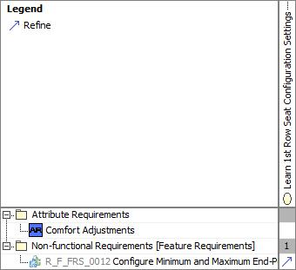

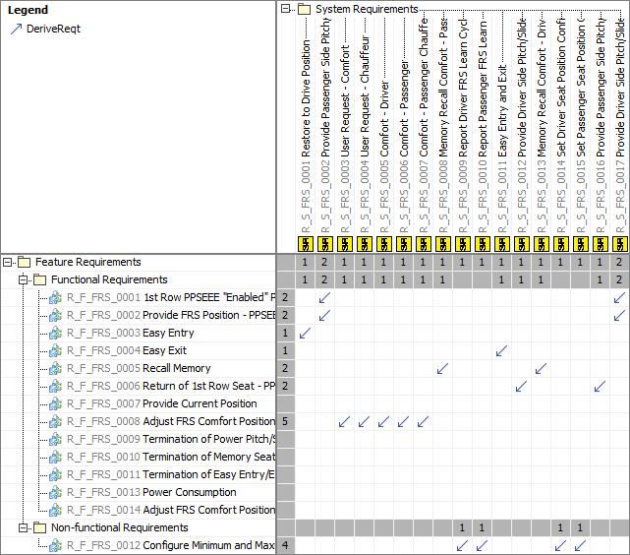

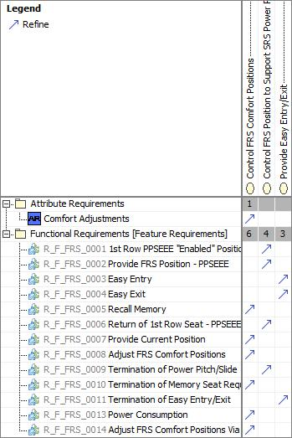

# Open Concerns

| ID | Concern Description | e-Tracker / Reference | Responsible | Status | Solution |
| --- | --- | --- | --- | --- | --- |
| 1 |  |  |  |  |  |

Table 24: Open Concerns *(Not supported by MagicDraw report generation)*

# Revision History

| Rev.  (revision) | Date | Description | Approved by | Responsible |
| --- | --- | --- | --- | --- |
| FD1 | 2021-11-17 | Removed Tilt from the Passenger Side of the variant descriptions for all CDX variants.  Added Market information for variant 9 as well as variant information.  Added the following Feature Requirement: Power Consumption  Edited the following Feature Requirement Description: Return of 1st Row Seat - PPSEEE |  | wdressel |
| FD2 | 2021-11-19 | Created the following Feature Requirement:  Adjust FRS Comfort Positions via Soft Button  Edited the Refined Relations Matrix so that the following feature functions were tied to use cases:  Adjust FRS Comfort Positions via Soft Button  Power Consumption |  | wdressel |
| FD3 | 2022-03-24 | Created new Feature Document for U71X programs only |  | ehern149 |

Table 25: Revision History

## Template Revisions

|  |  |  |  |  |
| --- | --- | --- | --- | --- |
| Version | Rev. | Date | Description | Responsible |
| 0 | 6 | 2015-05-26 | * Chapter “Feature Overview” and made a 2nd level heading. * Chapter “Feature Modeling” divided into 3 subchapter (“Scenarios”, “Use Cases”, “State Machines”) for different modeling methods | Jbaden1 |
| 0 | 7 | 2015-05-27 | * Table of Content updated * Template Revision History chapter added | Jbaden1 |
| 0 | 8 | 2015-07-02 | * Section “Unsettled Issues” added | Alevin7 |
| 0 | 9 | 2015-08-04 | * Section “Feature Variants” added * Section “Feature Boundary Diagram” renamed to “Feature Context Diagram” * Document Properties adapted to match needs of VBA macros | Jbaden1, Awegman1 |
| 1 | 0 | 2015-09-11 | * Section “Feature Variants” reworked * Feature Goals removed. Only “Safety Goals“ chapter remains. * Heading 2 formatting issues corrected. * Requirements / Use Cases Listing removed from traceability chapter. * Formatting of attribute table in Notation chapter corrected * Open Topics / Known Issues chapter moved to the end | Jbaden1 |
| 1 | 1 | 2015-11-16 | * Table-Styles removed (for smooth VSEM import) * Some clean-up of sections “Purpose” and “Audience” | Awegman1, jbaden1 |
| 1 | 2 | 2016-02-26 | * Minor corrections based on lessons learned from CC and PCL pilot (e.g. section market/regions) and discussion with Functional Safety Team (purpose of feature) * Footer corrected * Boundary diagram interface chapter renamed to influences. | Jbaden1 |
| 1 | 3 | 2016-02-26 | * Minor corrections after review with Whitney Keith from Functional Safety team | Jbaden1 |
| 1 | 4 | 2016-03-10 | * Some cleanup of meta-data in Word Properties | Jbaden1 |
| 1 | 5 | 2016-03-10 | * Footer formatting corrected (Issue 19) * Results from review with Functional Safety Team incorporated (Issue 20). | jbaden1 |
| 1 | 6 | 2016-04-18 | * Scenario Template added | Jbaden1 |
| 1 | 7 | 2016-04-18 | * Chapter “Operation Modes and States” moved before “Use Case” section. | Jbaden1 |
| 1 | 8 | 2016-04-18 | * Broken Wiki links repaired. | Jbaden1 |
| 2 | 0 | 2016-05-19 | * Adapted to Specification_Macros.dotm V2.0 * Requirements Templates chapter (ch. 1.7.1) no longer has an attribute table, but refers directly to the Wiki.. | Jbaden1 |
| 2 | 1 | 2016-06-10 | * Table for Context Diagram modified (lists external entities and Influence Description only) | Jbaden1 |
| 2 | 2 | 2016-07-08 | * Template version added to footer * Several hints added to the various sections * Findings from Functional Safety Team incorporated. * RE_SafetyRequirement style added | Jbaden1 |
| 2 | 3 | 2016-09-21 | * Update from Functional Safety Team incorporated (“Lessons Learned”, “System Behaviors for HARA”) | Jbaden1 |
| 2 | 4 | 2016-11-15 | * Update from Functional Safety Team incorporated (“Lessons Learned”, “System Behaviors for HARA”) * Explanatory notes made more formal | Jbaden1 |
| 3 |  |  | Skipped to synchronize with Specification_Macros.dotm |  |
| 4 |  |
| 5 | 0 | 2017-01-13 | * Meta data updated for specification macros, version 3.1 * SW Unit chapter removed for the time being * Green boxes added for user hints | Jbaden1 |
| 5 | 1 | 2017-01-18 | * Minor editorial changes | Jbaden1 |
| 6 | 0 | 2017-02-03 | * CR48: Chapter 6 renamed from “Safety” to “Functional Safety”. New sub-chapter “Safety” introduced in Non-Functional Requirements section | Jbaden1 |
| 6 | 0 | 2017-04-28 | * CR7: “RequirementsTraceability” chapter removed | Jbaden1 |
| 6 | 0 | 2017-11-15 | * CR32/53: New Cover Sheet + Disclaimer replaces FAP-150 like ones. * CR75: Some rewording -> Terminology to Glossary, Notation -> Document Conventions * CR49: Rename “Assumptions & Constraints” to “Assumptions” * CR74: Safety Assumptions added to chapter 6. * CR58: Add function allocation column to Logical Architecture chapter | Jbaden1 |
| 6 | 0 | 2018-01-31 | * CR63: Updated links to Functional Safety Sharepoint | Jbaden1 |
| 6 | 0 | 2018-07-24 | * CR69: Add FSR to FeatureDoc * CR64: Add new section "Design Requirements" to Function Spec and Feature Spec | Jbaden1 |
| 6 | 0 | 2018-08-06 | * CR53: some corrections for metada and formatting | Jbaden1 |
| 6 | 0 | 2018-09-28 | * Broken links to RE Wiki repaired | Jbaden1 |
| 6 | 0 | 2018-10-31 | * Cover sheet and footer more GIS like. Functional Safety team feedback incorporated:   + New subsections “Functional Safety Requirements, (Decomposed) FSRs and Parameters / Values   + Removal of “Logical Architecture” | Jbaden1 |
| 6 | 0 | 2018-12-12 | * FSR template removed, now as a macro in the Specification_Macros.dotm | Jbaden1 |
| 6 | 0a | 2019-05-23 | * Re-introduce “Logical Architecture” (for Functional Safety) | Jbaden1 |
| 6 | 0b | 2019-06-26 | * Chapter “Logical Elements” in “Logical Architecture” section added (FuSa CR 15136240) | Jbaden1 |
| 6 | 0c | 2019-03-22 | * Chapter “Decomposed FSRs” renamed to “ASIL Decomposition of Functional Safety Requirements” and moved beneath Chapter “Functional Safety Requirements”. Explanatory text improved. | Jbaden1 |
| 6 | 0c | 2019-04-05 | * Some wording in ASIL decomposition table modified. Description of fields in that table improved. | Jbaden1 |
| 6 | 0c | 2019-06-24 | * “Input Requirements” section modified (table approach as for the other RE templates). * “References” and “Glossary” chapter moved to the “Introduction” chapter. | Jbaden1 |
| 6 | 0c | 2019-07-02 | * "Important" box added on cover sheet which points to the macros | Jbaden1 |
| 6 | 0c | 2019-07-02 | * Subsection “Error Handling” removed form chapter “Feature Requirements”->”Functional Requirements” (teams are free to create their own substructure of that section). Note tells author not to forget about error handling. * Hint for chapter “Feature Variants” improved reworded upon request from Functional Safety Team. | Jbaden1 |
| 6 | 0c | 2019-05-11 | * Copyright notice shortened and moved to cover sheet and added to footer (to be compliant [with Ford copyright guidelines](http://www.fgti.ford.com/client/NewFGTI/CopyrightNotice.html)) * Term “Disclaimer” no longer used for what is actually only a copyright notice | Jbaden1 |
| 6 | 0c | 2019-22-11 | * Chapter “Input Requirements/Documentst: minor modifications (examples added), Word comment removed” | Jbaden1 |
| 6 | 0c | 2019-12-05 | * Upstream Documents section added to “Input Requirements/Documents” table * Custom style table formatting removed * Hint on system behaviors modified as requested from FuSa team | Jbaden1 |
| 6 | 0c | 2019-12-09 | * Term “Upstream Documents” replaced by “Attribute Requirements” in “Input Requirements/Documents” table * ASIL Decomposition table replaced by a version, which get not corrupted during VSEM import. | Jbaden1 |
| 6 | 0c | 2019-12-10 | * In ch. “Functional Safety Requirements” Word reference Id by Word reference text replaced.. | Jbaden1 |
| 6 | 1a | 2020-02-12 | * New chapter “Cybersecurity” added. | Jbaden1 |
| 6 | 1a | 2020-03-03 | * All User Hints formatted using style “RE_UserHint” to enable automatic removal by a macro. | Jbaden1 |
| 6 | 1a | 2020-03-04 | * Chapter “Cloud Connectivity Data Analytics Requirements” added upon request by D. Crockett/J. Rawlings | Jbaden1 |
| 6 | 1a | 2020-03-09 | * Missing doc property “LatestSigMappingID” and “LatestAisInterfaceID” added * doc property “CopyrightDate” re-formatted to text and copyright date field in footer corrected * Version numbering re-initialized as 0.1 * Init value of version/revision date set to “yyyy/mm/dd” instead of “yyyy-mm-dd” to be in line with the “Edit Document Property” dialog * type of document property for latest IDs changed to number instead of text | Jbaden1 |
| 6 | 1b | 2020-03-17 | * Chapter “Functional Architecture” renamed to “Functional Decomposition” * New MBSE terminology introduced: “Feature Level”, “Function Level” and “Component Level” renamed to “Concept Level”, “Logical Level” and “Technology Level” | Jbaden1 |
| 6 | 1b | 2020-07-03 | * CR31: Chapter “Traceability Matrix” added. | Jbaden1 |
| 6 | 1b | 2020-23-09 | * CR28: Alignment to [*FFSG01.10 Feature Document Guideline*](https://azureford.sharepoint.com/sites/GlobalFunctionalSafety/Released%20Templates%20Guidelines%20and%20Examples/Guidelines/FFSG01.10_FeatureDocument_Guideline.pdf) for how to apply the Feature Doc template for Functional Safety. New section “Classification of Chapters” added. “Active Tilt Control” Example in section “Logical Architecture” updated based on input from HARA training. | Jbaden1 |
| 6 | 1b | 2020-25-11 | * Reference to process definition in Stages added to “How to Use” section on cover sheet. User hints removed from “Document Purpose” chapter. * RE-Wiki links mostly replaced by Stages links, links to Functional Safety Sharepoint updated | Jbaden1 |

# Appendix

## Definitions

| **Definition** | **Description** |
| --- | --- |
| "Enabled" Position | "For the 1st Row Seat, it is the target position for the 1st row seat to enable the pitch/slide action of the 2nd row seat to be able to complete. Also when the seat Fore/Aft position is in Enabled Fore/Aft Position and the seat Incline/Recline position is in Enabled Incline/Recline Position.  For the 2nd Row Seat, it is the target position for the 2nd row seat to be able to start the pitch/slide action." |
| "Initial" Position | The position that each seat starts in before the Power Pitch/Slide is requested.  Also, the position to which the 1st row seat shall return when the Power Pitch/Slide Return is commanded. |
| "Reset" Position | The position to which the 2nd row seat should return when the Power Pitch/Slide return is commanded. |
| 1R | First Row |
| 8-Way Driver | Comfort Seat adjustments with 8 movements for Driver seat |
| 8-Way Passenger | Comfort Seat adjustments with 8 movements for Passenger seat |
| 10-Way Driver | Comfort Seat adjustments with 10 movements for Driver seat |
| Activation Sequence Profile | The calibrated sequence profile of seat movement activation. The seat movements will occur in the order that is dictated by the profile. |
| Calf Rest End Point Range | The target range +/- tolerance for the end points of the learned minimum and maximum end points of the seat calf rest. |
| Calf Rest Move Angle | The angle (in degrees/s) that the FRS moves the seat Calf Rest comfort setting due to user request. |
| Calf Rest Obstacle Reverse Distance | The distance the "FRS Driver Calf Rest Actuator" will reverse when the actuator detects an obstacle impeding its intended motion. |
| Calf Rest Obstacle Reverse Target Position Delta | The target calf rest position delta +/- tolerance that indicates the FRS calf rest position has moved by " Calf Rest Obstacle Reverse Distance" from the position where the obstacle was detected. |
| Calf Rest Target Position Delta | The target calf rest position delta +/- tolerance that represents the FRS calf rest position is at the position indicated by "DesiredPositionCalfRest". |
| Cuhion Tilt Obstacle Reverse Target Position Delta | The target seat cushion tilt position delta +/- tolerance that indicates the FRS cushion tilt position has moved by "Cushion Tilt Obstacle Reverse Distance" from the position where the obstacle was detected. |
| CurrentPositionCalfRest | The current position of the calf rest. An increase in this value indicates forward movement and a decrease in this value indicates rearward movement of the calf rest. |
| CurrentPositionForeAft | The current position of the seat on the seat track. An increase in this value indicates forward movement of the seat and a decrease in this value indicates rearward movement of the seat. |
| CurrentPositionHeadrestForeAft | The current position of the headrest fore/aft. An increase in this value indicates forward movement and a decrease in this value indicates rearward movement of the headrest. |
| CurrentPositionHeadrestHeight | The current position of the headrest height. An increase in this value indicates upward movement and a decrease in this value indicates downward movement of the headrest. |
| CurrentPositionHorizontalLumbar | The current position of the lumbar fore/aft. An increase in this value indicates forward movement and a decrease in this value indicates rearward movement of the lumbar support. |
| CurrentPositionInclineRecline | The current position of the seat back. An increase in this value indicates rearward movement of the seat back and a decrease in this value indicates forward movement of the seat back. |
| CurrentPositionLeftThigh | The current position of the left thigh support. An increase in this value indicates forward movement and a decrease in this value indicates rearward movement of the left thigh support. |
| CurrentPositionRightThigh | The current position of the right thigh support. An increase in this value indicates forward movement and a decrease in this value indicates rearward movement of the right thigh support. |
| CurrentPositionSeatHeight | The current position of the seat height. An increase in this value indicates upward movement of the seat and a decrease in this value indicates downward movement of the seat. |
| CurrentPositionThoracic | The current position of the thoracic support. An increase in this value indicates forward movement and a decrease in this value indicates rearward movement of the thoracic support. |
| CurrentPositionTilt | The current position of the seat tilt. An increase in this value indicates tilt in the upwards direction and a decrease in this value indicates a tilt in the downward direction. |
| CurrentPositionVerticalLumbar | The current position of the lumbar up/down. An increase in this value indicates upward movement and a decrease in this value indicates downward movement of the lumbar support. |
| Cushion Tilt End Point Range | The target range +/- tolerance for the end points of the learned minimum and maximum end points of the seat cushion tilt. |
| Cushion Tilt Obstacle Reverse Distance | The distance the "FRS Driver Cushion Tilt Actuator" will reverse when the actuator detects an obstacle impeding its intended motion. |
| Cushion Tilt Target Position Delta | The target cushion tilt position delta +/- tolerance that represents the FRS cushion tilt position is at the position indicated by "DesiredPositionTilt". |
| Drive Position | The driver seat position set by the driver for driving. Also the initial position of the driver seat prior to movement for Easy Entry and Exit. |
| Drive Position Target Position Delta | The target fore/aft position delta +/- tolerance for for Easy Entry and Exit at which the FRS fore/aft position is at the "Drive Position". |
| DSM | Driver Seat Module |
| Easy Entry and Exit Distance | The distance the FRS Driver ForeAft Actuator" will move in the aft direction when Easy Entry and Exit is requested. |
| Easy Entry and Exit Target Position Delta | The target fore/aft position delta +/- tolerance for Easy Entry and Exit at which the FRS fore/aft position has:  1a) Moved by "Easy Entry and Exit Distance" from the previous position OR  1b) Moved to the aft end-point if the aft end-point is within "Easy Entry and Exit Distance" of the "Drive Position". |
| Enabled Fore/Aft Position | The fore/aft position of the FRS that enables the SRS to fully pitch/slide forward. |
| Enabled Incline/Recline Position | The incline/recline position of the FRS that enables the SRS to fully pitch/slide forward. |
| Fore/Aft End Point Range | The target range +/- tolerance for the end points of the learned minimum and maximum end points of the seat fore/aft. |
| Fore/Aft Move Timing | The time (in mm/s) that the FRS moves the seat Fore/Aft comfort settings due to user request. |
| Fore/Aft Obstacle Reverse Distance | The distance the "FRS Driver ForeAft Actuator" will reverse when the actuator detects an obstacle impeding its intended motion. |
| Fore/Aft Obstacle Reverse Target Position Delta | The target fore/aft position delta +/- tolerance that indicates the FRS fore/aft position has moved by "Fore/Aft Obstacle Reverse Distance" from the position where the obstacle was detected. |
| Fore/Aft Target Enabled Position Delta for Pitch/Slide | The target fore/aft position delta, with a +/- tolerance, for pitch/slide that represents the FRS fore/aft position is at the "Enabled Fore/Aft Position". |
| Fore/Aft Target Initial Position Delta for Pitch/Slide | The target fore/aft position delta, with a +/- tolerance, for pitch/slide that represents the FRS fore/aft position is at the "Initial Fore/Aft Position". |
| Fore/Aft Target Position Delta | The target fore/aft position delta +/- tolerance that represents the FRS fore/aft position is at the position indicated by "DesiredPositionForeAft". |
| Headrest Fore/Aft End Point Range | The target range +/- tolerance for the end points of the learned minimum and maximum end points of the headrest fore/aft. |
| Headrest Fore/Aft Obstacle Reverse Distance | The distance the "FRS Driver Headrest Fore/Aft Actuator" will reverse when the actuator detects an obstacle impeding its intended motion. |
| Headrest Fore/Aft Obstacle Reverse Target Position Delta | The target headrest fore/aft position delta +/- tolerance that indicates the FRS headrest fore/aft position has moved by " Headrest Fore/Aft Obstacle Reverse Distance" from the position where the obstacle was detected. |
| Headrest Fore/Aft Target Position Delta | The target headrest fore/aft position delta +/- tolerance that represents the FRS headrest fore/aft position is at the position indicated by "DesiredPositionHeadrestForeAft". |
| Headrest Forward/Rearward | The time (in mm/s) that the FRS moves the seat Headrest comfort settings forward/rearward due to user request. |
| Headrest Height End Point Range | The target range +/- tolerance for the end points of the learned minimum and maximum end points of the headrest height. |
| Headrest Height Obstacle Reverse Distance | The distance the "FRS Driver Headrest Height Actuator" will reverse when the actuator detects an obstacle impeding its intended motion. |
| Headrest Height Obstacle Reverse Target Position Delta | The target headrest height position delta +/- tolerance that indicates the FRS headrest height position has moved by " Headrest Height Obstacle Reverse Distance" from the position where the obstacle was detected. |
| Headrest Height Target Position Delta | The target headrest height position delta +/- tolerance that represents the FRS headrest height position is at the position indicated by "DesiredPositionHeadrestHeight". |
| Headrest Up/Down | The time (in mm/s) that the FRS moves the seat Headrest comfort settings up/down due to user request. |
| High speed | Approximately more than 52 mph (83 kph) |
| Horizontal Lumbar End Point Range | The target range +/- tolerance for the end points of the learned minimum and maximum end points of the seat horizontal lumbar. |
| Horizontal Lumbar Obstacle Reverse Distance | The distance the "FRS Driver Horizontal Lumbar Actuator" will reverse when the actuator detects an obstacle impeding its intended motion. |
| Horizontal Lumbar Obstacle Reverse Target Position Delta | The target horizontal lumbar position delta +/- tolerance that indicates the FRS lumbar position has moved by "Horizontal Lumbar Obstacle Reverse Distance" from the position where the obstacle was detected. |
| Horizontal Lumbar Target Position Delta | The target horizontal lumbar position delta +/- tolerance that represents the FRS horizontal lumbar position is at the position indicated by "DesiredPositionHorizontalLumbar". |
| Incline/Recline End Point Range | The target range +/- tolerance for the end points of the learned minimum and maximum end points of the seat incline/recline. |
| Incline/Recline Move Angle | The angle (in degrees/s) that the FRS moves the seat Incline/Recline comfort setting due to user request. |
| Incline/Recline Obstacle Reverse Distance | The distance the "FRS Driver InclineRecline Actuator" will reverse when the actuator detects an obstacle impeding its intended motion. |
| Incline/Recline Obstacle Reverse Target Position Delta | The target incline/recline position delta +/- tolerance that indicates the FRS incline/recline position has moved by " Incline/Recline Obstacle Reverse Distance" from the position where the obstacle was detected. |
| Incline/Recline Target Enabled Position Delta for Pitch/Slide | The target incline/recline position delta +/- tolerance for pitch/slide that represents the FRS incline/recline position is at the "Enabled Incline/Recline Position". |
| Incline/Recline Target Initial Position Delta for Pitch/Slide | The target incline/recline position delta +/- tolerance for pitch/slide that represents the FRS incline/recline position is at the "Initial Incline/Recline Position". |
| Incline/Recline Target Position Delta | The target incline/recline position delta +/- tolerance that represents the FRS incline/recline position is at the position indicated by "DesiredPositionInclineRecline". |
| Initial Fore/Aft Position | The fore/aft position of the FRS prior to being requested to move forward by SRS. |
| Initial Incline/Recline Position | The incline/recline position of the FRS prior to being requested to move forward by SRS. |
| Learn Calf Rest Time | The maximum allowed time for the Comfort Position Controller to learn one end point of the seat calf rest. |
| Learn Cushion Tilt Time | The maximum allowed time for the Comfort Position Controller to learn one end point of the seat cushion tilt. |
| Learn Fore/Aft Time | The maximum allowed time for the Comfort Position Controller to learn one end point of the seat fore/aft. |
| Learn Headrest Fore/Aft Time | The maximum allowed time for the Comfort Position Controller to learn one end point of the headrest fore/aft. |
| Learn Headrest Height Time | The maximum allowed time for the Comfort Position Controller to learn one end point of the headrest height. |
| Learn Horizontal Lumbar Time | The maximum allowed time for the Comfort Position Controller to learn one end point of the seat horizontal lumbar. |
| Learn Incline/Recline Time | The maximum allowed time for the Comfort Position Controller to learn one end point of the seat incline/recline. |
| Learn Left Thigh Time | The maximum allowed time for the Comfort Position Controller to learn one end point of the seat left thigh. |
| Learn Right Thigh Time | The maximum allowed time for the Comfort Position Controller to learn one end point of the seat right thigh. |
| Learn Seat Height Time | The maximum allowed time for the Comfort Position Controller to learn one end point of the seat height. |
| Learn Thoracic Time | The maximum allowed time for the Comfort Position Controller to learn one end point of the seat thoracic. |
| Learn Vertical Lumbar Time | The maximum allowed time for the Comfort Position Controller to learn one end point of the seat vertical lumbar. |
| Left Thigh End Point Range | The target range +/- tolerance for the end points of the learned minimum and maximum end points of the seat left thigh. |
| Left Thigh Obstacle Reverse Distance | The distance the "FRS Driver Left Thigh Actuator" will reverse when the actuator detects an obstacle impeding its intended motion. |
| Left Thigh Obstacle Reverse Target Position Delta | The target left thigh position delta +/- tolerance that indicates the FRS left thigh position has moved by " Left Thigh Obstacle Reverse Distance" from the position where the obstacle was detected. |
| Left Thigh Target Position Delta | The target left thigh position delta +/- tolerance that represents the FRS left thigh position is at the position indicated by "DesiredPositionLeftThigh". |
| Low speed | Approximately 12 to 36 mph (19 to 58 kph ) |
| Lumbar Move Timing | The time (in mm/s) that the FRS moves the seat Lumbar comfort settings due to user request. |
| Manually Adjustable Motor | These motors can include the following:  1) Thoracic  2) Lumbar  3) Calf Raise  4) Left Thigh Extension  5) Right Thigh Extension  6) Back Bolsters  7) Cushion Bolsters |
| Maximum Calf Rest Soft Position | The position at which further calf rest actuation in the positive direction will not be permitted on the passenger's side. |
| Maximum Driver Fore/Aft Soft Position | The position at which further fore/aft actuation in the positive direction will not be permitted on the driver's side. |
| Maximum Driver Headrest Fore/Aft Soft Position | The position at which further headrest fore/aft actuation in the positive direction will not be permitted on the driver's side. |
| Maximum Driver Headrest Height Soft Position | The position at which further headrest height actuation in the positive direction will not be permitted on the driver's side. |
| Maximum Driver Horizontal Lumbar Soft Position | The position at which further horizontal lumbar actuation in the positive direction will not be permitted on the driver's side. |
| Maximum Driver Incline/Recline Soft Position | The position at which further incline/recline actuation in the positive direction will not be permitted on the driver's side. |
| Maximum Driver Left Thigh Soft Position | The position at which further left thigh actuation in the positive direction will not be permitted on the driver's side. |
| Maximum Driver Right Thigh Soft Position | The position at which further right thigh actuation in the positive direction will not be permitted on the driver's side. |
| Maximum Driver Seat Height Soft Position | The position at which further seat height actuation in the positive direction will not be permitted on the driver's side. |
| Maximum Driver Seat Tilt Soft Position | The position at which further seat tilt actuation in the positive direction will not be permitted on the driver's side. |
| Maximum Driver Thoracic Soft Position | The position at which further thoracic support actuation in the positive direction will not be permitted on the driver's side. |
| Maximum Driver Vertical Lumbar Soft Position | The position at which further vertical lumbar actuation in the positive direction will not be permitted on the driver's side. |
| Medium speed | Approximately 36 mph to 52 mph (58 to 83 kph) |
| Minimum Calf Rest Soft Position | The position at which further calf rest actuation in the negative direction will not be permitted on the passenger's side. |
| Minimum Driver Fore/Aft Soft Position | The position at which further fore/aft actuation on the in the negative direction will not be permitted on the driver's side. |
| Minimum Driver Headrest Fore/Aft Soft Position | The position at which further headrest fore/aft actuation on the in the negative direction will not be permitted on the driver's side. |
| Minimum Driver Headrest Height Soft Position | The position at which further headrest height actuation on the in the negative direction will not be permitted on the driver's side. |
| Minimum Driver Horizontal Lumbar Soft Position | The position at which further horizontal lumbar actuation on the in the negative direction will not be permitted on the driver's side. |
| Minimum Driver Incline/Recline Soft Position | The position at which further incline/recline actuation on the in the negative direction will not be permitted on the driver's side. |
| Minimum Driver Left Thigh Soft Position | The position at which further left thigh actuation on the in the negative direction will not be permitted on the driver's side. |
| Minimum Driver Right Thigh Soft Position | The position at which further right thigh actuation on the in the negative direction will not be permitted on the driver's side. |
| Minimum Driver Seat Height Soft Position | The position at which further seat height actuation on the in the negative direction will not be permitted on the driver's side. |
| Minimum Driver Seat Tilt Soft Position | The position at which further seat tilt actuation on the in the negative direction will not be permitted on the driver's side. |
| Minimum Driver Thoracic Soft Position | The position at which further thoracic support actuation on the in the negative direction will not be permitted on the driver's side. |
| Minimum Driver Vertical Lumbar Soft Position | The position at which further vertical lumbar actuation on the in the negative direction will not be permitted on the driver's side. |
| Motor stall | Motor Stall occurs when the user makes a supervised adjustment and a motor cannot move in the desired position. This will most-likely occur because of an obstacle. |
| PPSEEE Pitch/Slide Process | The sequence of events where the 1st and 2nd row seats move to allow easy access to the 3rd row. |
| PPSEEE Return Process | The sequence of events following a 3rd row ingress/egress where the 1st and 2nd row seats reset themselves to post ingress/egress. |
| Right Thigh End Point Range | The target range +/- tolerance for the end points of the learned minimum and maximum end points of the seat right thigh. |
| Right Thigh Obstacle Reverse Distance | The distance the "FRS Driver Right Thigh Actuator" will reverse when the actuator detects an obstacle impeding its intended motion. |
| Right Thigh Obstacle Reverse Target Position Delta | The target right thigh position delta +/- tolerance that indicates the FRS right thigh position has moved by " Right Thigh Obstacle Reverse Distance" from the position where the obstacle was detected. |
| Right Thigh Target Position Delta | The target right thigh position delta +/- tolerance that represents the FRS right thigh position is at the position indicated by "DesiredPositionRightThigh". |
| SCMB_PSM | Passenger Seat Module |
| Seat Height End Point Range | The target range +/- tolerance for the end points of the learned minimum and maximum end points of the seat height. |
| Seat Height Obstacle Reverse Distance | The distance the "FRS Driver Seat Height Actuator" will reverse when the actuator detects an obstacle impeding its intended motion. |
| Seat Height Obstacle Reverse Target Position Delta | The target seat height position delta +/- tolerance that indicates the FRS height position has moved by " Seat Height Obstacle Reverse Distance" from the position where the obstacle was detected. |
| Seat Height Target Position Delta | The target seat height position delta +/- tolerance that represents the FRS height position is at the position indicated by "DesiredPositionSeatHeight". |
| Seat Height Timing | The time (in mm/s) that the FRS moves the seat height comfort settings due to user request. |
| Seat Tilt Timing | The time (in mm/s) that the FRS moves the seat tilt comfort settings due to user request. |
| term | A representation of a Concept expressed in Natural Language. In the vocabulary of a Domain of Discourse a term enables common understanding of domain concepts. |
| term glossary | A term glossary is a table of agreed upon definitions for terms used in project development that may provide clarity or avoid confusion to stakeholders. |
| Thoracic End Point Range | The target range +/- tolerance for the end points of the learned minimum and maximum end points of the seat thoracic. |
| Thoracic Obstacle Reverse Distance | The distance the "FRS Driver Thoracic Actuator" will reverse when the actuator detects an obstacle impeding its intended motion. |
| Thoracic Obstacle Reverse Target Position Delta | The target thoracic position delta +/- tolerance that indicates the FRS thoracic position has moved by " Thoracic Obstacle Reverse Distance" from the position where the obstacle was detected. |
| Thoracic Target Position Delta | The target thoracic position delta +/- tolerance that represents the FRS thoracic position is at the position indicated by "DesiredPositionThoracic". |
| TLA | Three Letter Acronym |
| Unsupervised Fore/Aft Obstacle Current Threshold | Current threshold that indicates an obstacle has been detected |
| Vertical Lumbar End Point Range | The target range +/- tolerance for the end points of the learned minimum and maximum end points of the seat vertical lumbar. |
| Vertical Lumbar Obstacle Reverse Distance | The distance the "FRS Driver Vertical Lumbar Actuator" will reverse when the actuator detects an obstacle impeding its intended motion. |
| Vertical Lumbar Obstacle Reverse Target Position Delta | The target vertical lumbar position delta +/- tolerance that indicates the FRS lumbar position has moved by "Vertical Lumbar Obstacle Reverse Distance" from the position where the obstacle was detected. |
| Vertical Lumbar Target Position Delta | The target vertical lumbar position delta +/- tolerance that represents the FRS vertical lumbar position is at the position indicated by "DesiredPositionVerticalLumbar". |
| Very Low Speed | Approximately 0 to 12 mph (0 to 19 kph) |

Table 26: Definitions used in this document

## Abbreviations

| **Abbr.** | **Stands for** |
| --- | --- |
| ATLA | Another Three Letter Acronym |
| FRS | First Row Seat |
| PPP | Personal Portable Profile |
| PPSEEE | Power Pitch Slide Easy Entry/Exit |
| SRS | Second Row Seat |
| TRS | Third Row Seat |

Table 27: Abbreviations used in this document

Document ends here.